MIS 374 – Business Systems Developer

Spring 2022

By MAVDEV

Ammar Lokhandwala

Maria Frausto

Michael Gurch

Victoria Sheraden

Vivian Bui

TEXAS ASSOCIATION OF CHARITABLE CLINICS (TXACC)

Interim Status Report

**SOFTWARE ACCESS**

**Website**

<https://txacc-resource.mn.co/>

**Admin Access**

Account: [resource@texasacc.org](mailto:resource@texasacc.org)

Password: Axpz!h97_S

SECTION 3B: ADMIN MATERIALS

**Table of Contents**

How to add Categories for the Resource Center 4

How to edit Categories for the Resource Center 14

How to delete Categories in the Resource Center 17

How to add Sections 19

How to edit Sections in the Resource Center 22

How to delete sections in the Resource Center 26

How to view all users and roles 28

How to login into the TXACC Mighty Network via a link 30

How to login to the TXACC Mighty Network via network search 32

How to login to the TXACC Mighty Network via email 37

How to invite a user via Email Invite 39

How to invite a user via a link 45

Our Recommendation 46

How to edit a user role in the “Home” network 47

How to edit a user role in the “Resources” network 50

How to edit a user role in the “Groups” network 53

How to remove a user from the Mighty Network – 1 56

How to remove a user from the Mighty Network – 2 59

Our Recommendation 61

How to edit User Profile 62

How to upload file(s) 65

How the File(s) upload process works 72

How to create a Group 76

How to enable the Chat feature inside of the Group 79

How to edit groups 82

How to delete a Group 86

How to add users to the Group Chat 88

How to search for group chats 91

Method 1 91

Method 2 92

Method 3 (To just see the groups you are in) 94

How to start Direct Message (DM) chat 97

How to attach files to chat 101

How to filter Resources 102

How to search for Resources via search bar 103

To search for files 104

How to Search for Clinics and their Members in the Resource Center 105

How to send Mass Announcements for the Resource Center 108

Method 1 – Create a post on the home page (also can do this in Groups! – same steps) 108

Method 2 – Create an article on the home page 111

Method 3 – Mass Message people on Mighty Networks Chat (also can do this in Resources! – same steps) 114

How to manage your notification preferences 118

How to create IT Questions 123

How to access and answer IT questions 126

Navigate to Network Settings 128

About Network Settings 130

Branding in Network – Network Settings 131

Branding in Resource – Resource Settings 133

Branding in Group – Group Settings 139

## How to add Categories for the Resource Center

1. Navigate to the [TXACC Mighty Networks home](https://network-7329457.mn.co/feed)
2. On the left side of the screen, click on the Resources link on the left nav bar

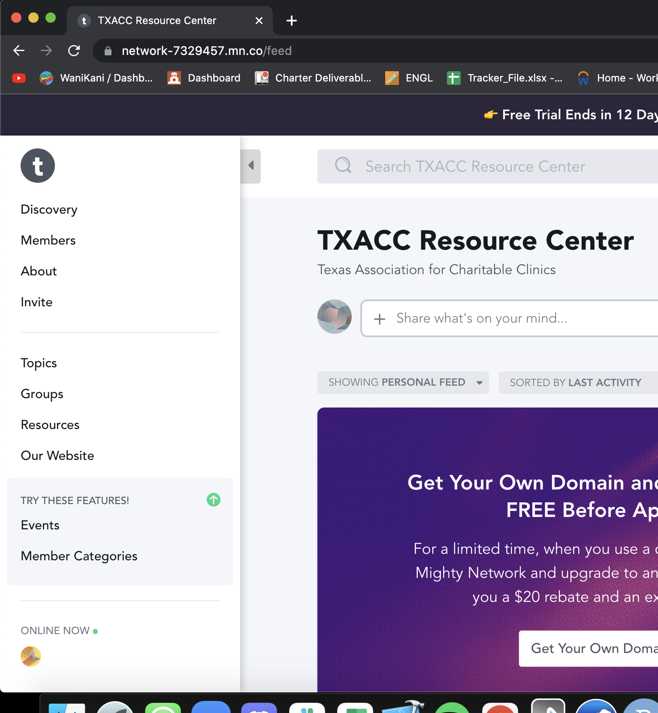

1. Next, click on the “+” symbol near the top right of the screen

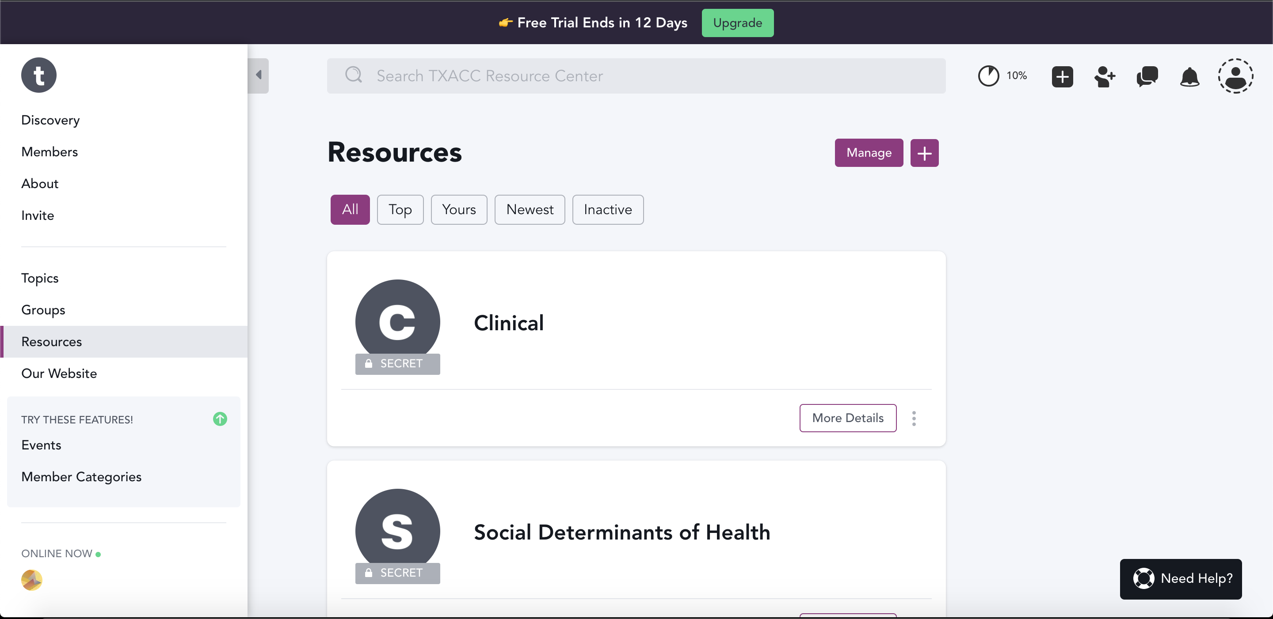

1. You should now see the screen below pop up on the right. Enter in the info as needed.
   1. NOTE: The only required field is “Resource Title”

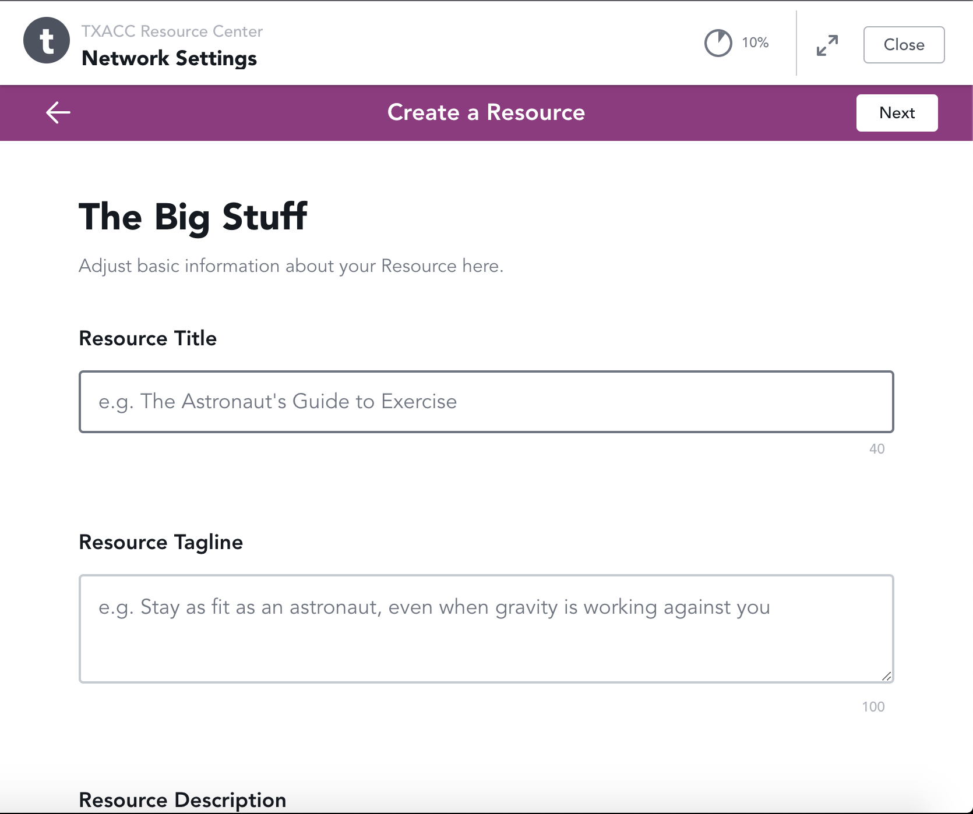

1. Next, scroll down a bit in the window and choose the appropriate level of privacy for the files/resources

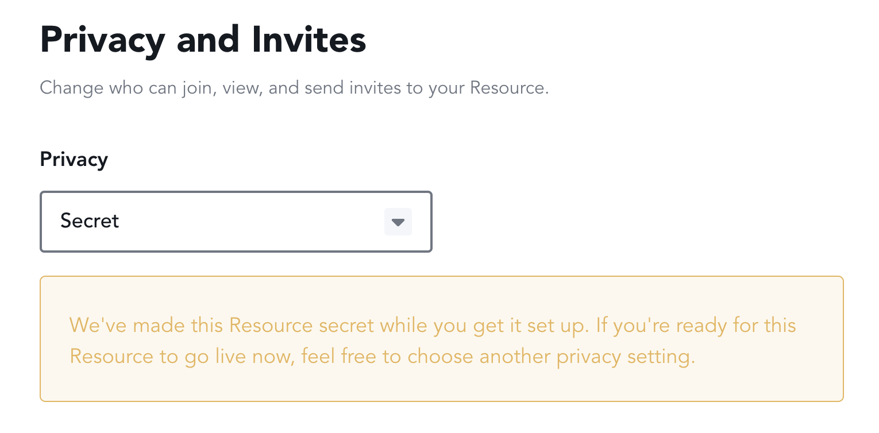

1. After that, scroll back up to the top of the window and click “Next”

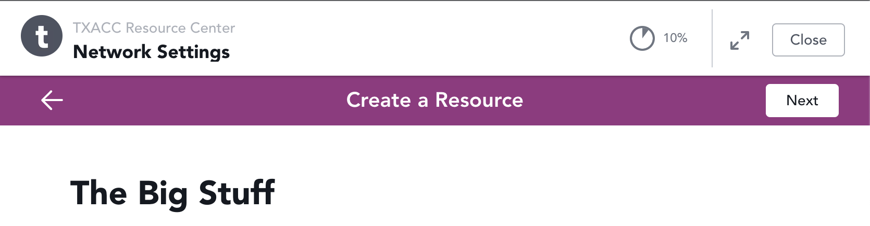

1. You should see a page like below. Click on the drop-down box for “Lesson”

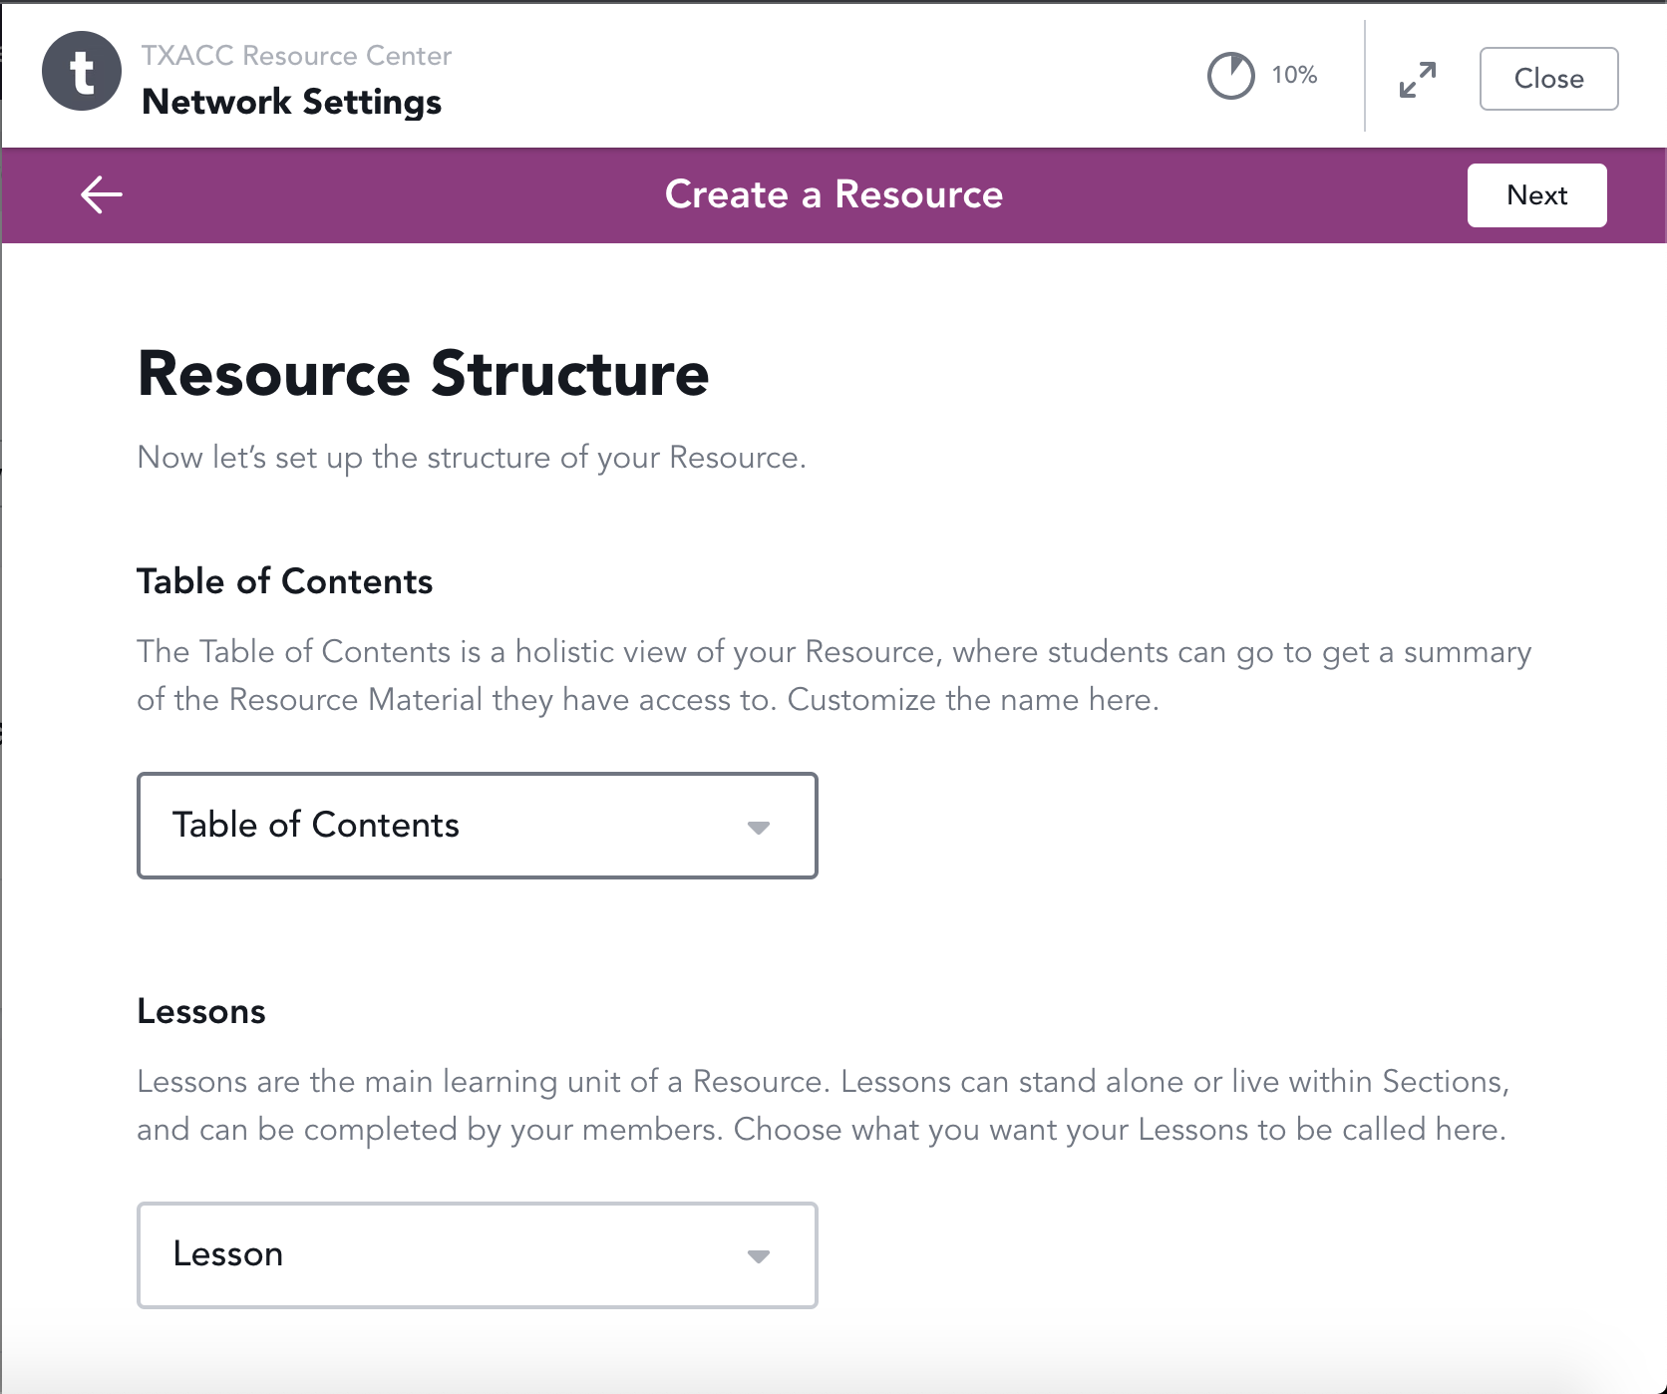

1. Click on “Add a Custom Name”

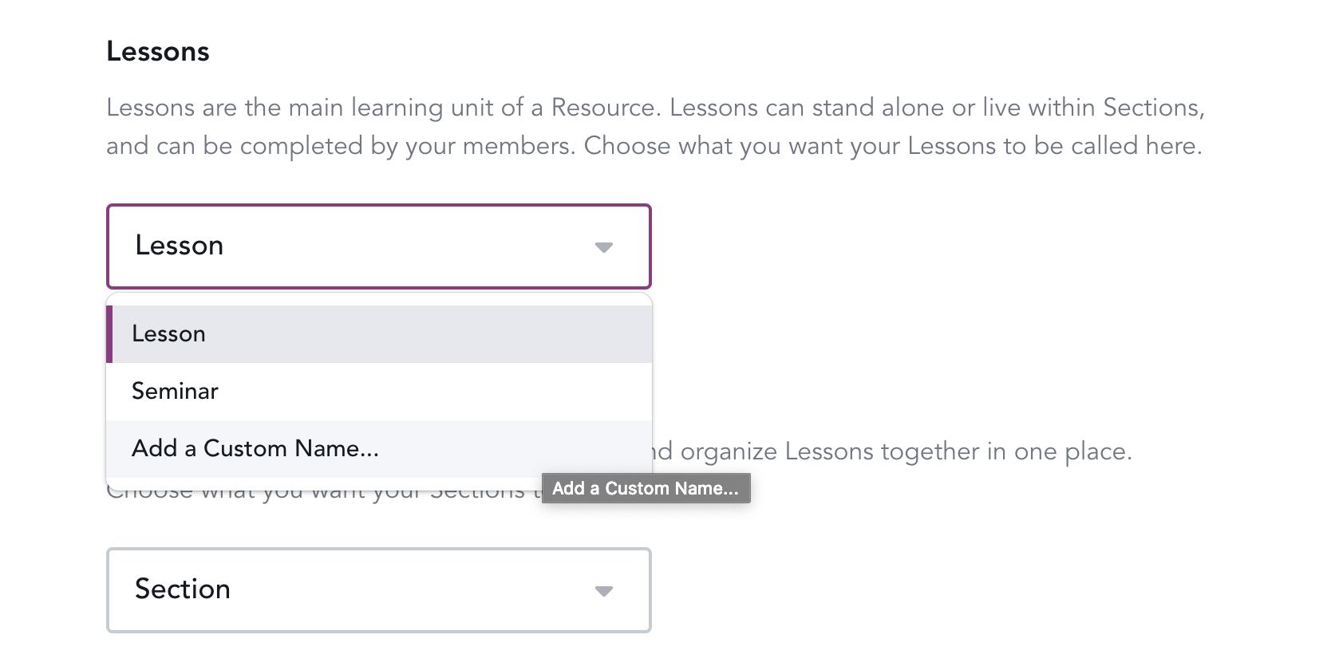

1. You should now see the fields below. Fill in with:
   1. Singular Name: **file**
   2. Indefinite Article Name: **a File**
   3. Plural Name: **Files**
   4. Possessive Plural Name: **Your Files**

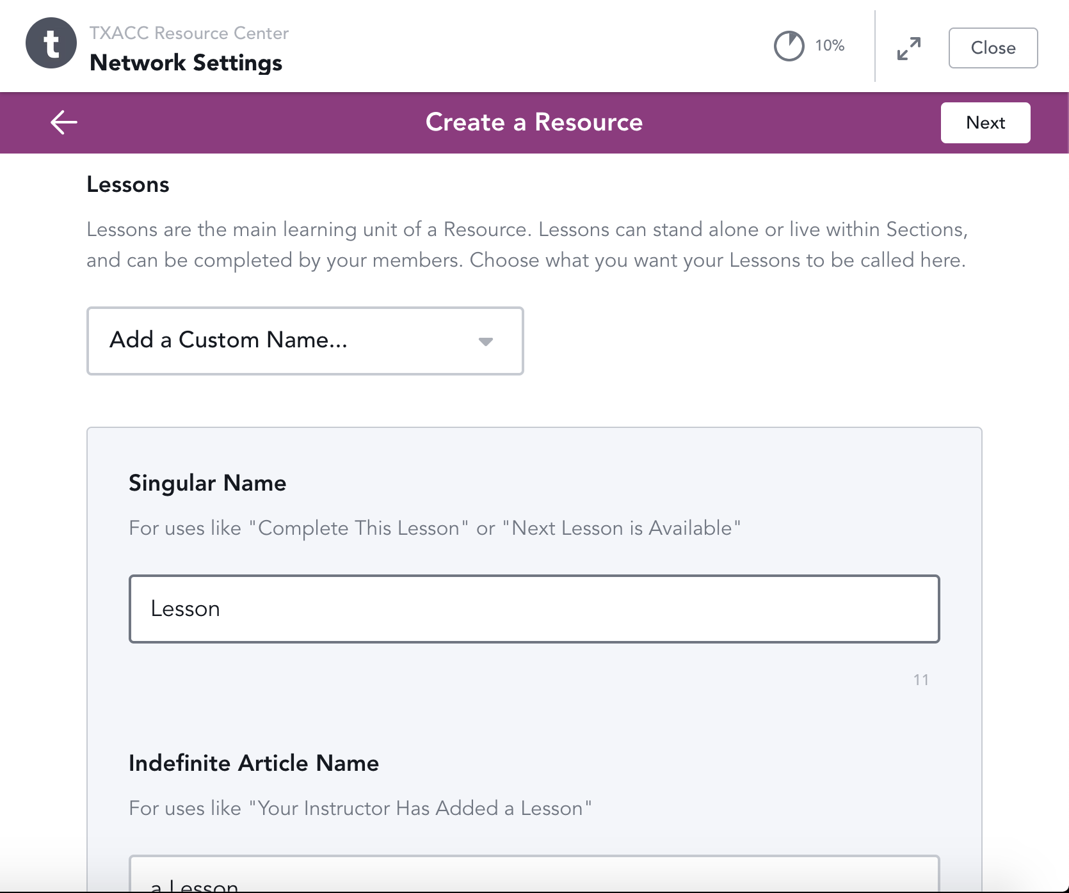

1. After you have done that, click on “Next” in the top right



1. You should now see this screen. Click on “finish”

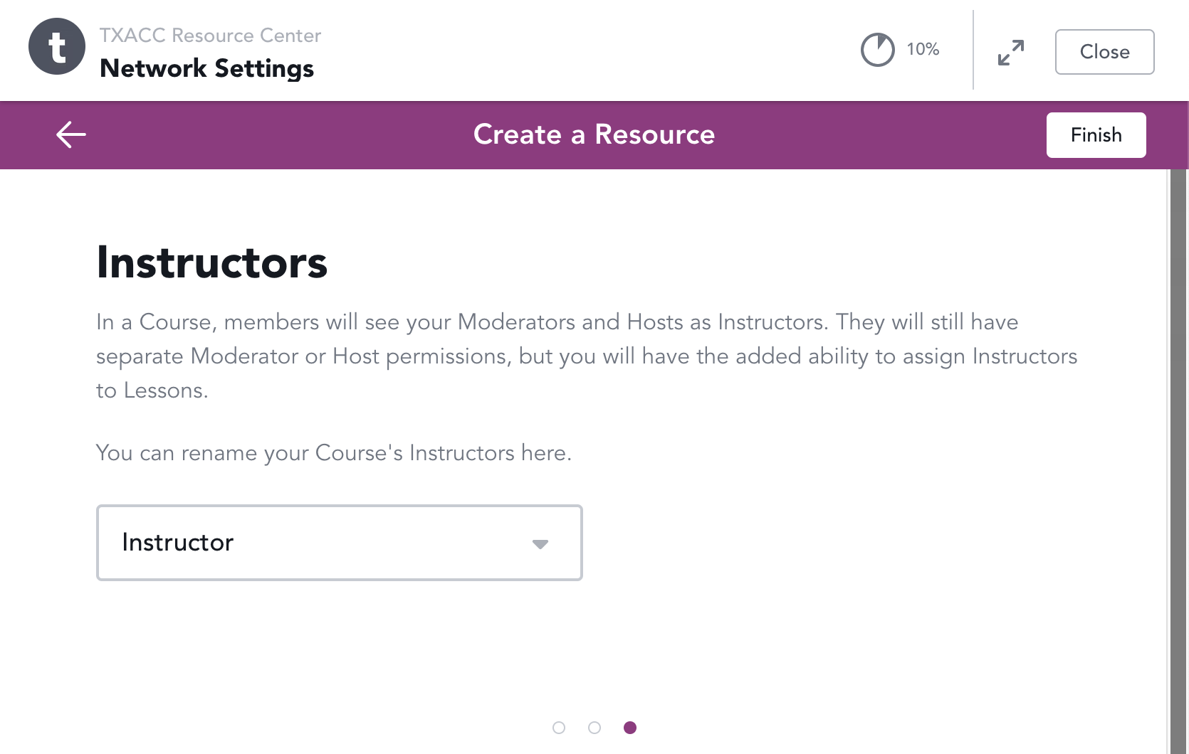

1. Your category has been created! Feel free to invite people or simply close the window

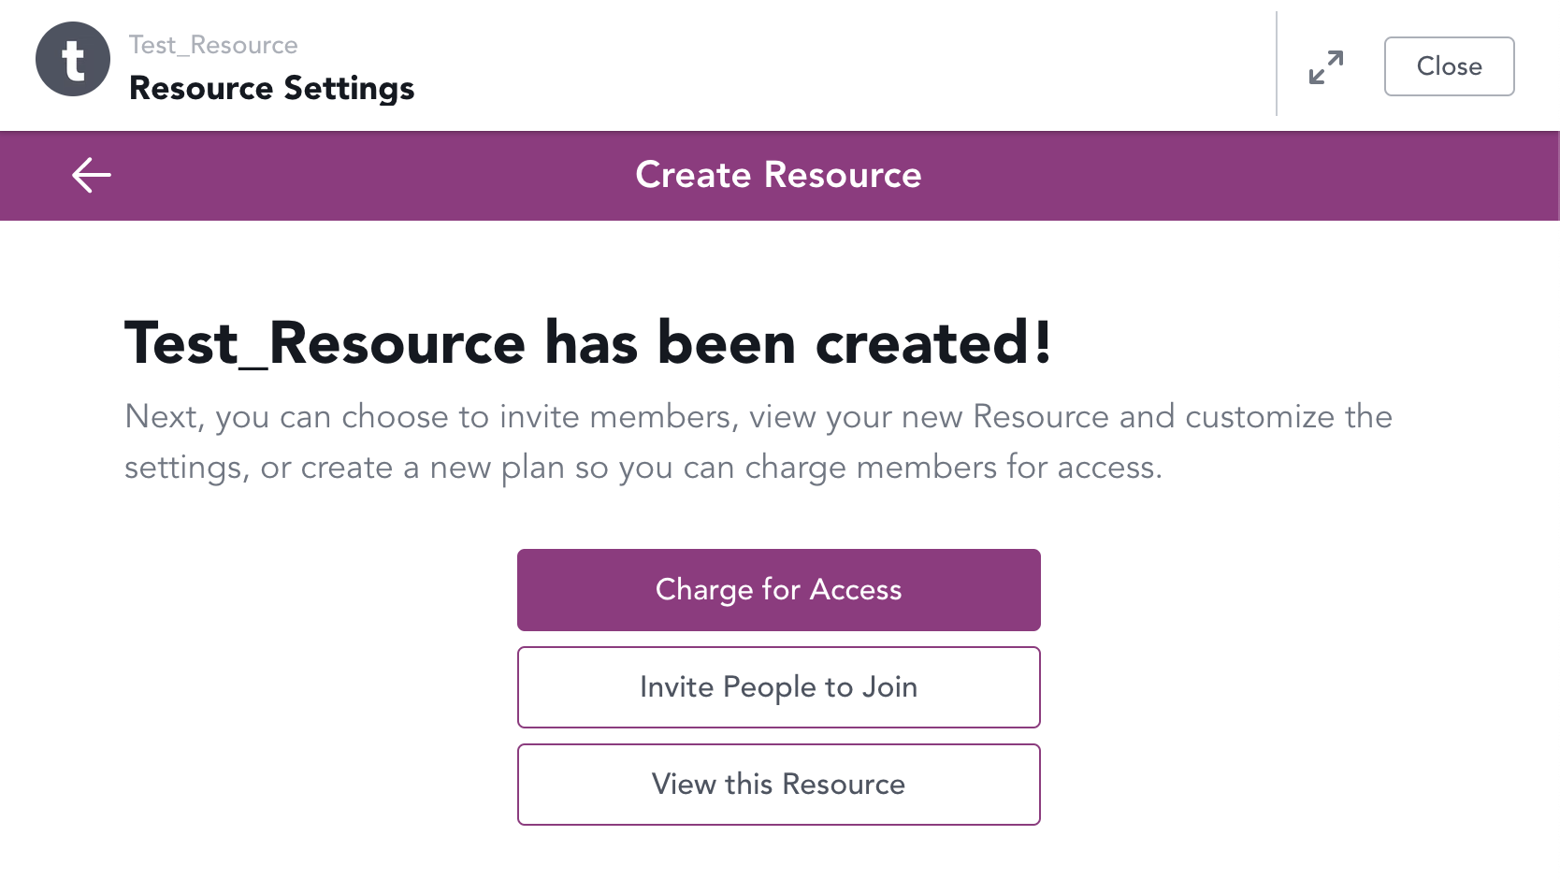

1. Lastly, you just need to turn on the chat for the category. This will be used for other things later. Click on “Manage” on the top right

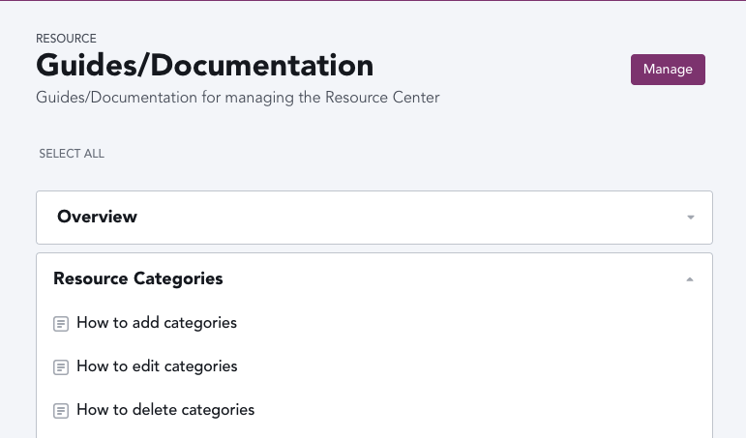

1. Click on “General Settings”

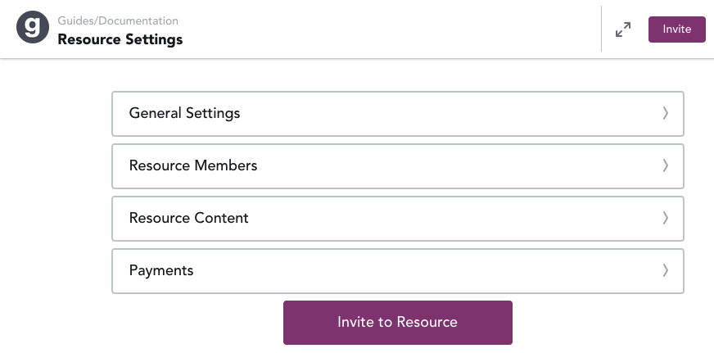

1. Scroll down until you see the “All Member Chat” option and make sure it’s turned on (If it’s turned off you just need to click the box and it will turn on)

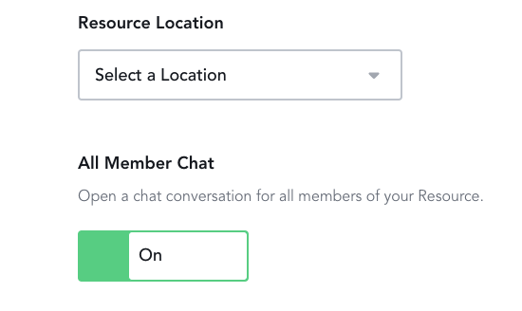

1. Next, you need to turn off the Activity Feed. It’s also in the General Settings if you scroll down a bit. Make sure it says “Off”

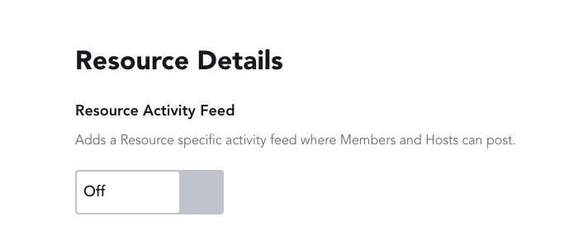

1. Don’t forget to save the change!

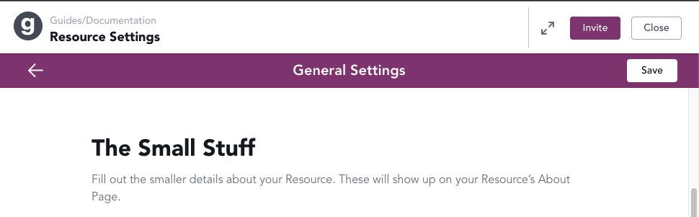

## How to edit Categories for the Resource Center

1. Navigate to the [TXACC Mighty Networks home](https://network-7329457.mn.co/feed)
2. On the left side of the screen, click on the Resources link on the left nav bar



1. Next, click the ellipses (three dots) on the bottom right of the resource

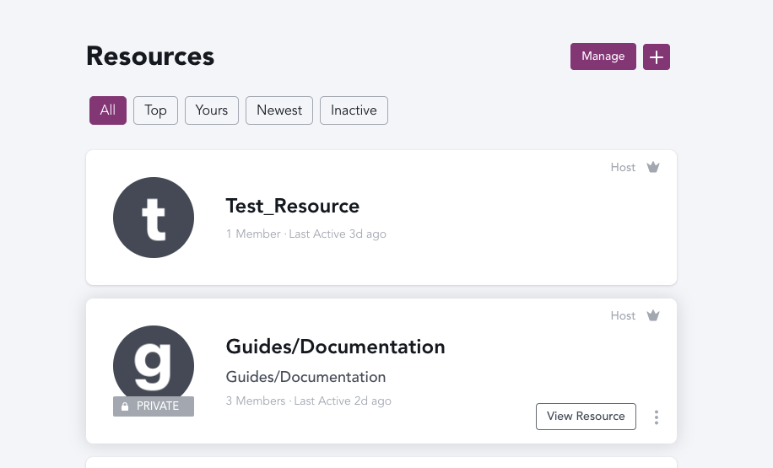

1. Click on “Settings”

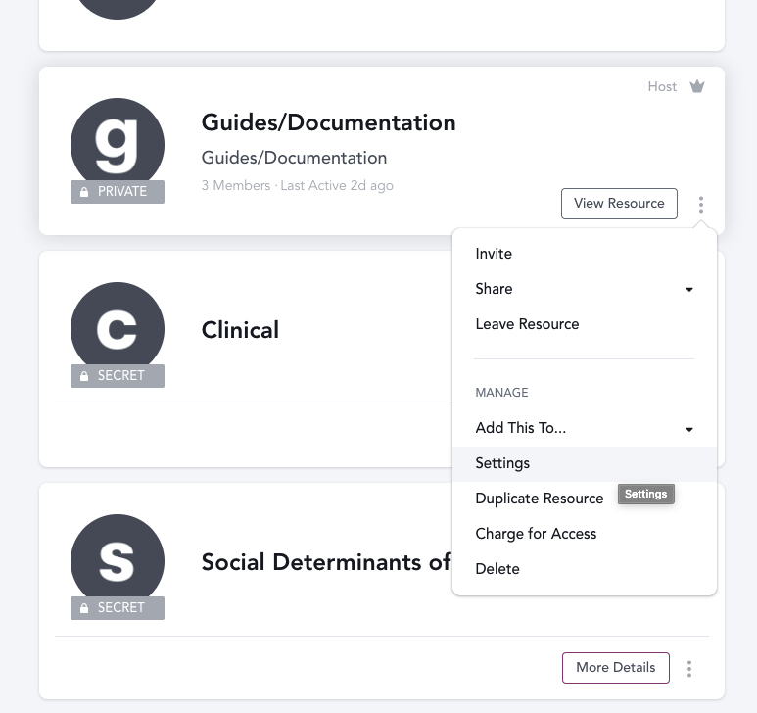

1. You should now see a large window pop on the right side of the screen. You can now edit the category from here!

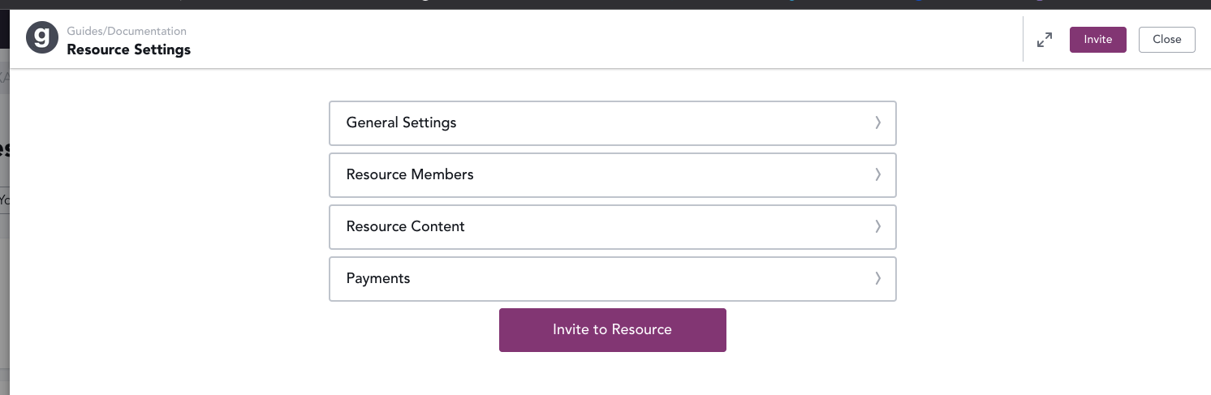

## How to delete Categories in the Resource Center

1. Navigate to the [TXACC Mighty Networks home](https://network-7329457.mn.co/feed)
2. On the left side of the screen, click on the Resources link on the left nav bar



1. Next, click the ellipses (three dots) on the bottom right of the resource



1. Click on “Delete”



## How to add Sections

1. Navigate to the [TXACC Mighty Networks home](https://network-7329457.mn.co/feed)
2. Go to the Resource you want to add a section to
3. Scroll to the bottom of the Resource and click “Add Section”

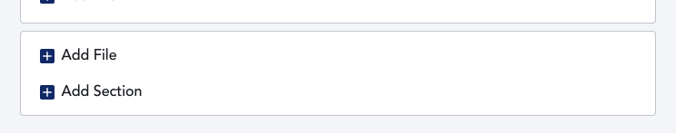

1. You should see a “New Section” Section pop up. Hover over it with your mouse and click “Edit”

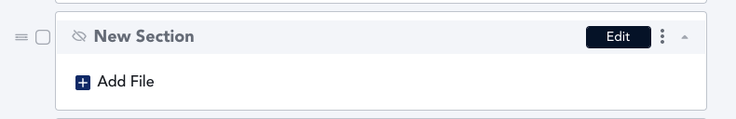

1. Edit the Section name to be what you want it



1. After you name it, click “Save” on the top right

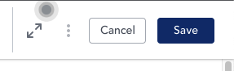

1. Next, if you want the Section to be visible to other people, scroll down to the section settings after clicking save. Click “Manage Section Settings”.

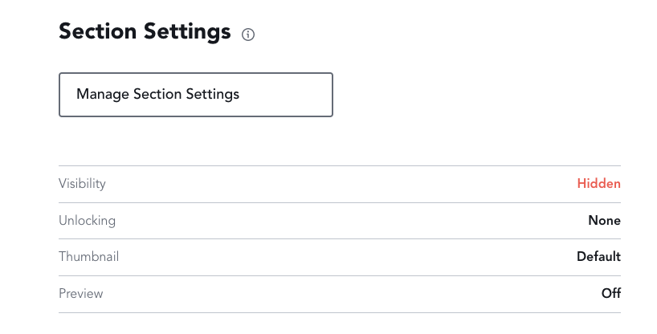

1. Make sure the Visibility is set to “Visible” if you want it to be viewable by other people in the Resource

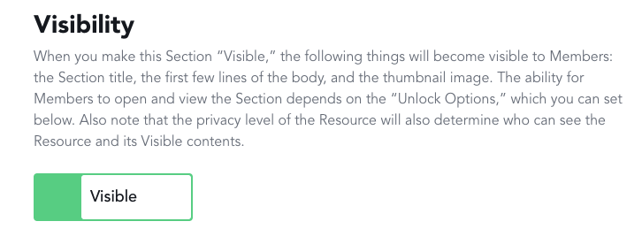

1. Lastly, click “Close” on the top right. You’ve now made a section ☺

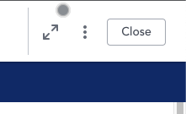

## How to edit Sections in the Resource Center

1. Navigate to the Resource where you want to edit the Section

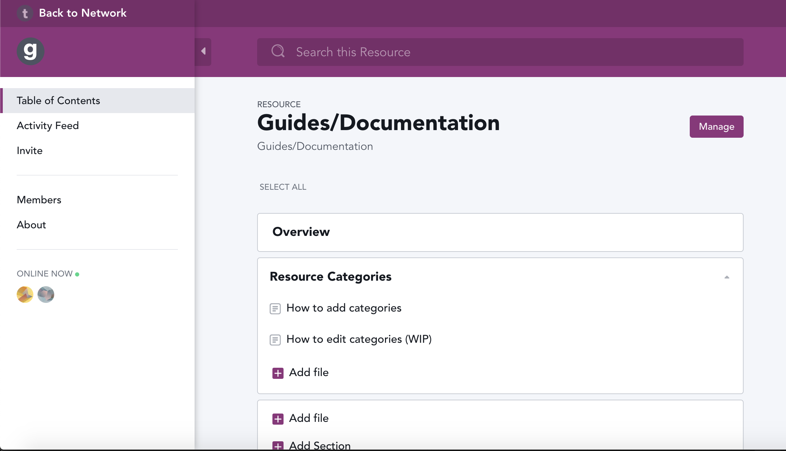

1. Hover over the section you want to edit with your mouse and click “Edit”

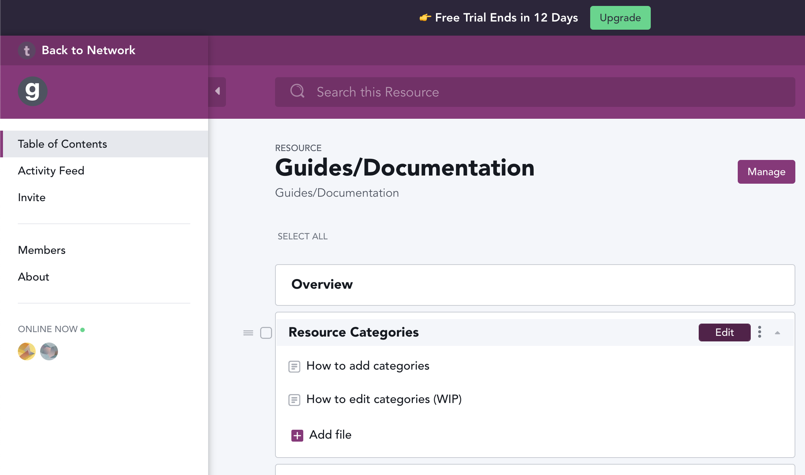

1. You should see this window that pops up on the right to edit the name or info by clicking on the text or the section below the name

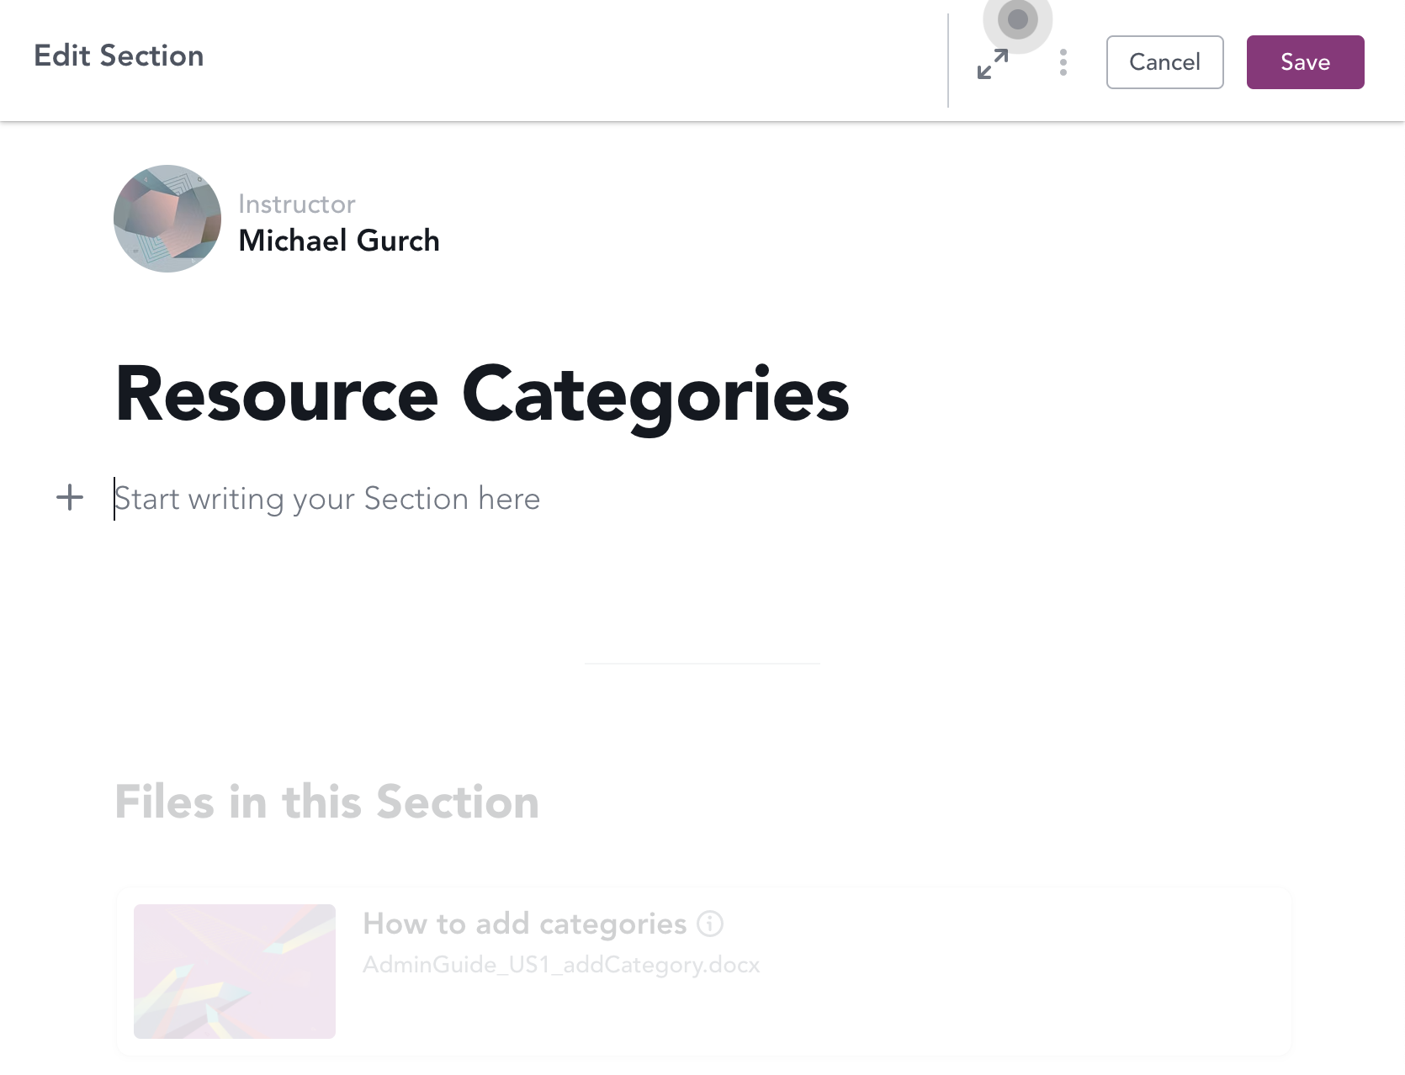

1. NOTE: You can edit more if you click “Cancel”, and scroll down to the bottom

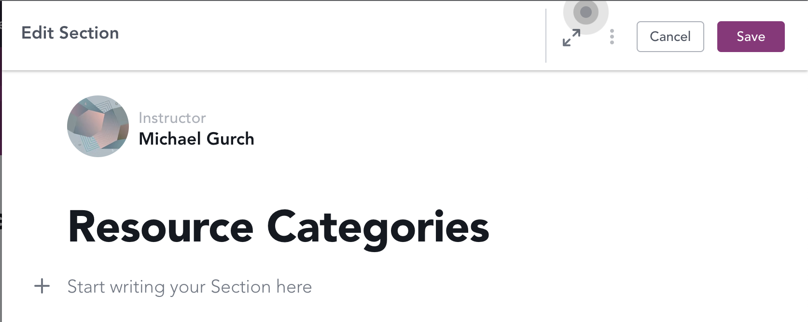

1. Keep scrolling down until you see this section:

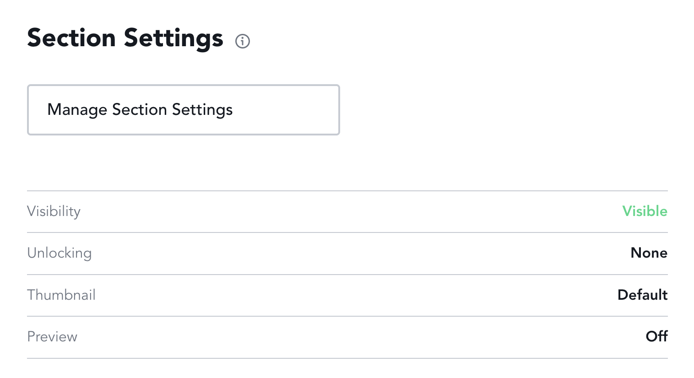

1. Click on “Manage Section Settings”



1. Here you can manage the visibility and unlock options

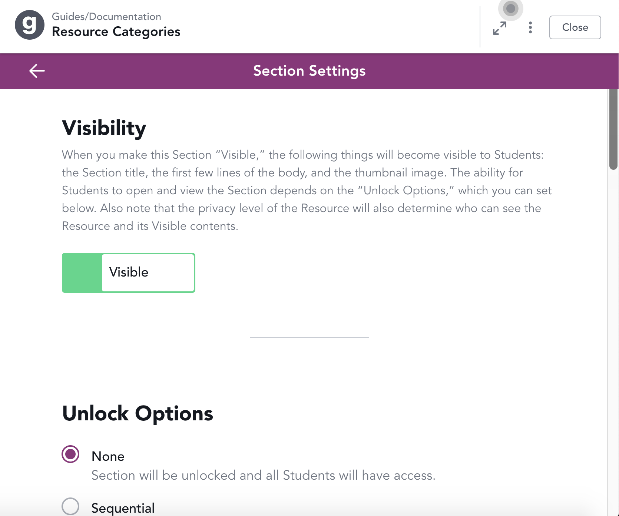

## How to delete sections in the Resource Center

1. Navigate to the Resource and find the section you want to delete



1. Hover over the section you want to delete with your mouse and click the ellipses (three dots)

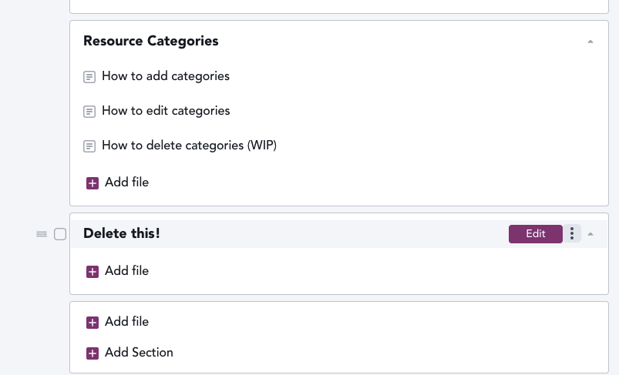

1. Lastly click the “Delete Section” that appears near the bottom of the pop up

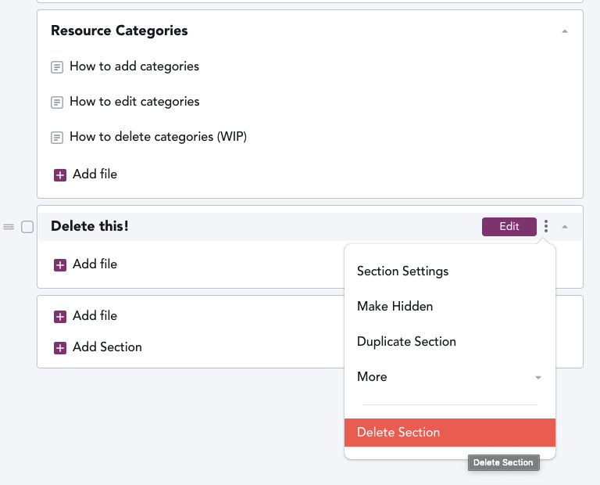

# How to view all users and roles

1. Navigate to the TXACC Might Network Home page: <https://txacc-resource.mn.co/feed>
2. Select the “Members” tab on the left-hand side of the screen.

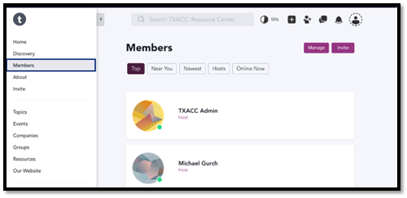

1. Here, you will see a list of all the users. Under the user’s name, you will see the role they have



1. At the top of the screen, you have a list of options that filter out specific groups of people

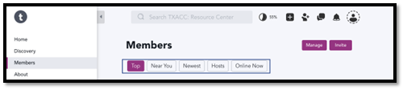

# How to login into the TXACC Mighty Network via a link

1. Navigate to the TXACC Mighty Network via this link: <https://txacc-resource.mn.co/feed>
2. Click on the “Sign In” button on the top right-hand side of the screen

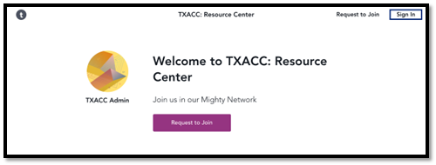

1. You will be prompted to login in with your Email and then your Password. There is also other sign in options (Google, Facebook, LinkedIn, Apple). The alternative options are sufficient, but this guide will show how to login with your Email and Password.

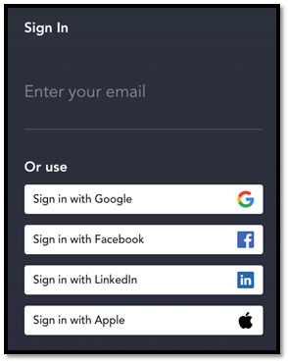

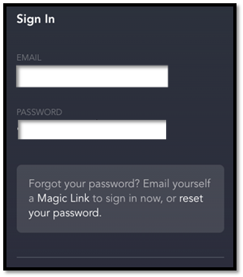

1. After inputting your Email and Password, click on the “Next” button. If you entered the correct credentials, you should be taken the TXACC Mighty Network Homepage.

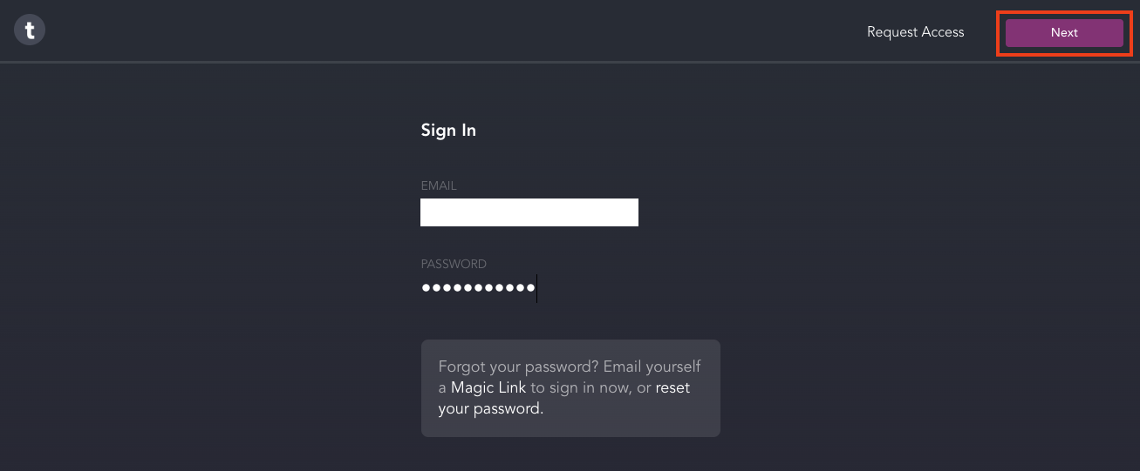

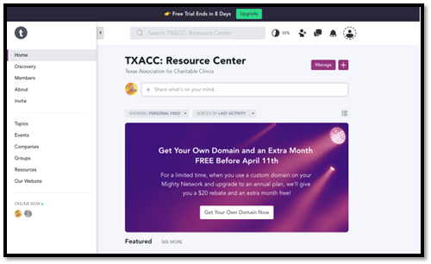

# How to login to the TXACC Mighty Network via network search

1. Navigate to the Mighty Network Homepage: <https://www.mightynetworks.com/> and click “Sign In” located at the top of the screen.

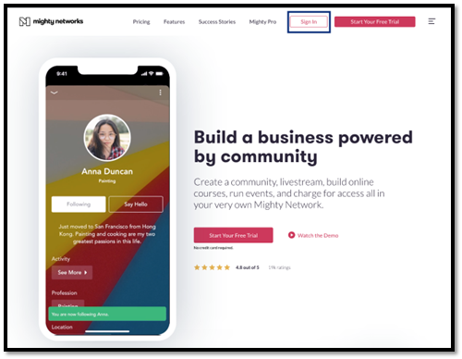

1. Click on “Search” and enter the name of the network - **TXACC: Resource Center**. Click on the first option that appears.

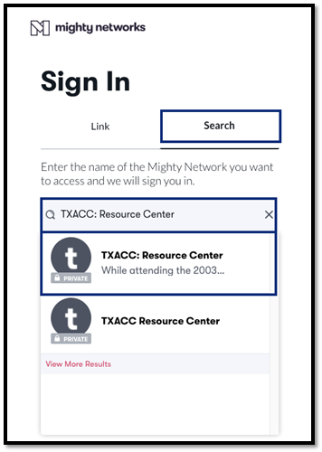

1. You will be prompted to login in with your Email and then your Password. There is also other sign in options (Google, Facebook, LinkedIn, Apple). The alternative options are sufficient, but this guide will show how to login with your Email and Password.





1. After inputting your Email and Password, click on the “Next” button. If you entered the correct credentials, you should be taken the TXACC Mighty Network Homepage.





# How to login to the TXACC Mighty Network via email

1. Go to <https://www.mightynetworks.com/>
2. Click on “Sign in” near the top right of the screen

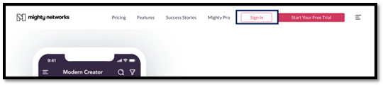

1. Enter your email in the text box and click send

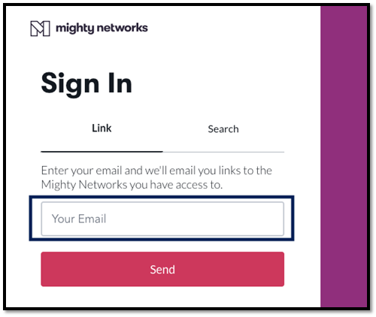

1. Navigate to your email and find the email with the subject “Your invitation to join me in TXACC Resource Center Dev” (Gmail example)

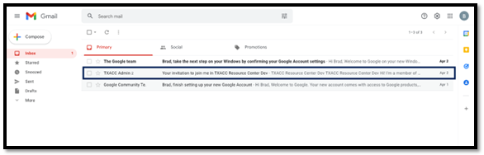

1. Once you open that email up, simply click the “Join Me” link

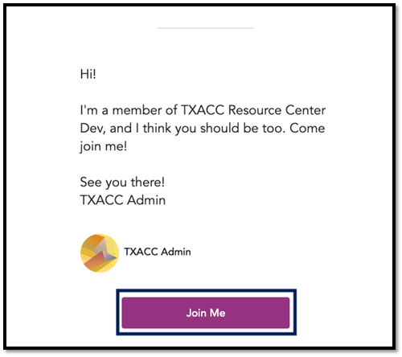

# How to invite a user with via Email Invite

1. Navigate to the TXACC Mighty Network Homepage: <https://txacc-resource.mn.co/feed>

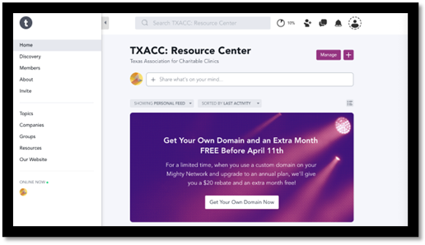

1. Locate the icon with person next to the plus sign and select “See More Invite Options”

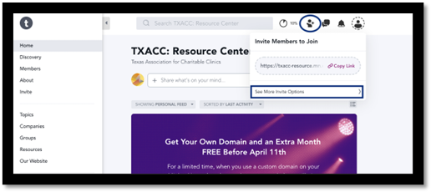

1. In the invite tab, type in the email of the user you would like to invite to the Mighty Network. Under the email input, a default message is displayed. You can edit this message, or leave it as is. Make sure to always invite users as “Members”. You can input up to 100 emails addresses in the box provided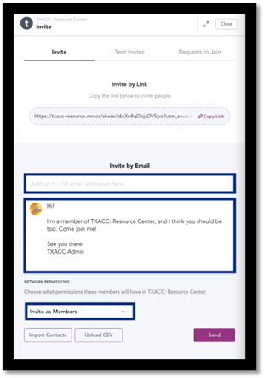
2. Once you enter the email, create custom message, and select the role this/these members will be in the network, hit the send button on the bottom left of the screen. After hitting send, a green box should appear at the bottom of the screen confirming the invite was sent.

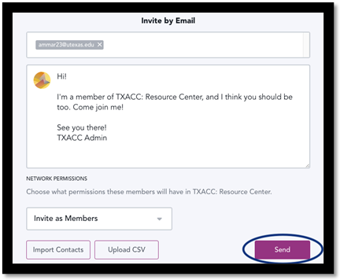

1. To verify the invite was sent, select the “Sent Invites” tab and locate the invite(s).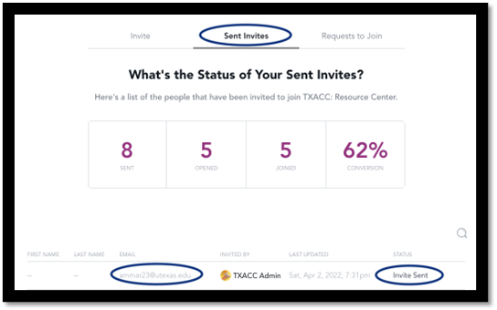
2. If you mistyped the email, or decide you don’t want the invitee to be a part of the network, hover over the specific user, click on the three dots to the right, and select “Revoke”. Confirm the revoke and check the status of the invite.

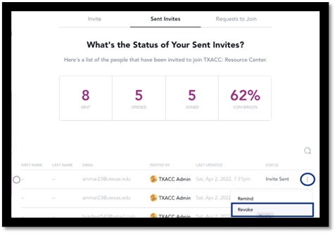

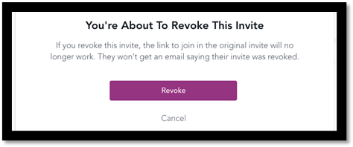



# How to invite a user via a link

1. Navigate to the TXACC Mighty Network Homepage: <https://txacc-resource.mn.co/feed>



1. Locate the icon with person next the plus sign. Click copy link.

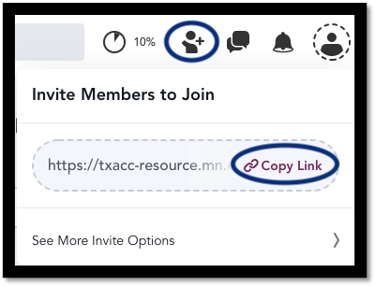

1. Once you have the link copied, you can send this link to the individual(s) through an email, text message, etc. The user will be promoted to join the network with a username and password.

## Our Recommendation

* To ensure the security of the network, we advise sending an invite via the email option. The email option generates a unique link for the user that only the specified user can use to join the network.

# How to edit a user role in the “Home” network

1. Navigate to the TXACC Mighty Network Home: <https://txacc-resource.mn.co/feed>
2. On the left-hand side, select the “Members” tab to see all the members in the network

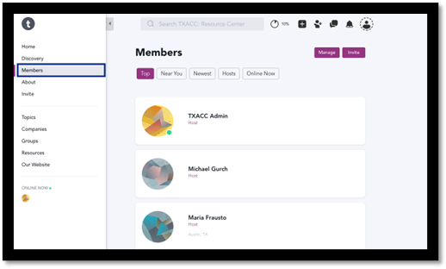

1. Hover over the specific member whose role you would like to change and click on the three dots located on the right-hand side. Click on the “Change Role” button. Under the name, you will see the role the user is assigned currently (Host, Moderator, and Member).

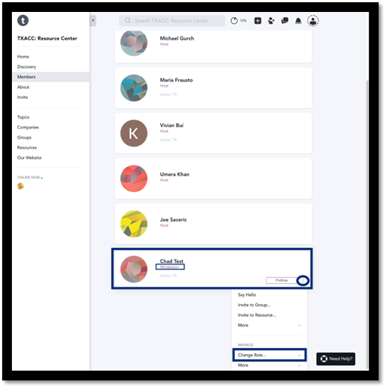

1. After clicking on the “Change Role” button, a menu will popup that will allow you to select the new role you want to make the user. A green popup should display when the role is changed successfully

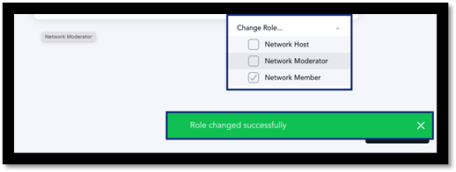

# How to edit a user role in the “Resources” network

1. Navigate to the TXACC Mighty Network Home: <https://txacc-resource.mn.co/feed>
2. On the left-hand side, select the “Resources” tab to see all the resources in the network

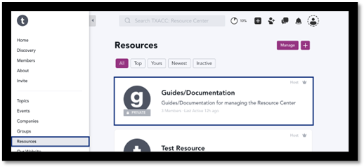

1. To preface, individual resources, such as the “Guides/Documentation” in the image above, have their own members. Whenever you want to change the role of a member in a resource, click on the individual resource. Then select “Members” on the left-hand side.

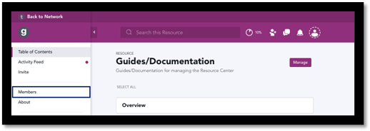

1. You will see a list of members within the resource. To change the role of members within a resource, it is the same process as stated in steps 3 and 4 in the “How to edit a user role in the “Home” Network, with one slight difference. When hovering over the user’s name, click the three dots on the right side, and select ‘Change Resource Role”. Then, select the role you would like this individual to be.

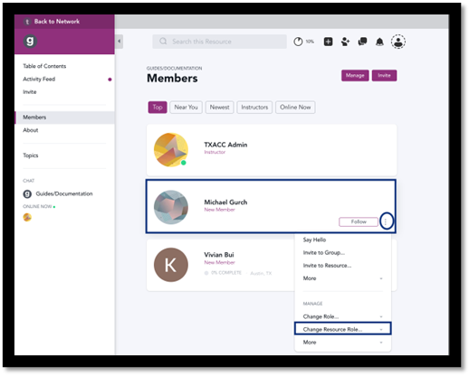

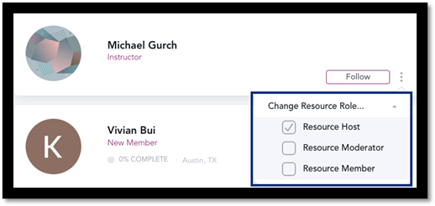

Note about “Public” Resources:

* Many of the resources that will be made for TXACC’s Resource Center will be available for all Mighty Network members to access. In this case, the only “Members” of “Public” resources will be those who need to edit the resource and add/remove files. An example of these people would be TXACC employees.
* Members within a "Public” resource will be assigned as “Resource Members” by default. It is NECESSARY for TXACC employees who will be making changes to be made “Resource Hosts” in all of the resources. The TXACC employee who makes a new resource will be in charge of adding other TXACC employees to the resource and changing their role to “Resource Host”

Note about “Private” Resources:

* If TXACC decides to make a resource “Private”, those members in there will be assigned as “Resource Members” by default. If you want to change their roles in the “Private” resource, it would be the same steps described above.

# How to edit a user role in the “Groups” network

1. Navigate to the TXACC Mighty Network Home: <https://txacc-resource.mn.co/feed>
2. On the left-hand side, select the “Groups” tab to see all the groups in the network

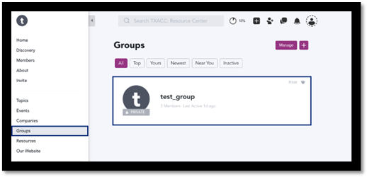

1. To preface, individual groups, such as the "test_group” in the image above, have their own members. Whenever you want to change the role of a member in a group, click on the individual group. Then select “Members” on the left-hand side.

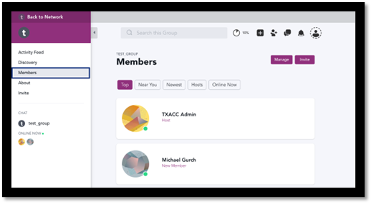

1. You will see a list of members within the group. To change the role of members within a group, it is the same process as stated in steps 3 and 4 in the “How to edit a user role in the “Home” Network, with one slight difference. When hovering over the user’s name, click the three dots on the right side, and select ‘Change Group Role”. Then, select the role you would like this individual to be.

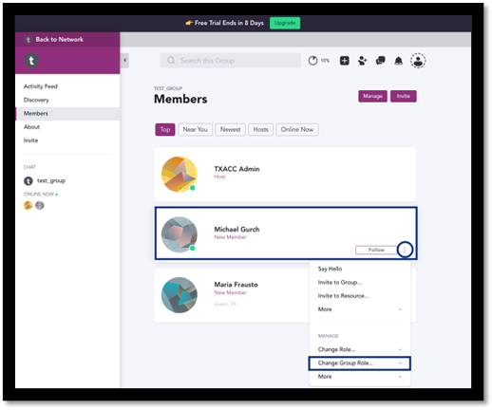

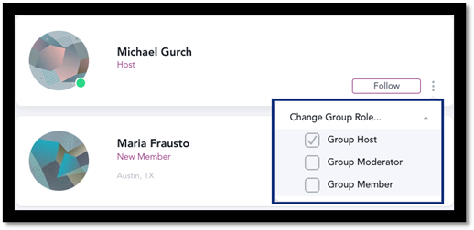

Note about “Public” Groups:

* If TXACC decides that some groups will be public, then members can freely roam those groups. All TXACC employees who need access to make edits to a group must be made “Group Hosts” in order to make these changes.

Note about “Private” Resources:

* Most groups will be considered “Private” for the TXACC Resource Center. In this case, all non-TXACC users must be assigned the role of "Member.” They will still be able to navigate the Group and send messages/upload files, but they will not have access to change any settings. All TXACC employees who will be monitoring groups will need to be placed in every group that is made and given the “Group Host” role. The steps to make these changes can be seen above.

# How to remove a user from the Mighty Network – 1

1. Navigate to the TXACC Mighty Network Home page: <https://txacc-resource.mn.co/feed>
2. Select the “Members tab on the left-hand size of the screen to view all the members in the network.

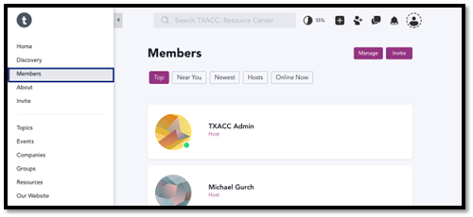

1. Find the specific user you would like to remove and click on their name.



1. At the top right, you will see three dots next to the “Close” button. Select the three dots and then select the “More” option under “Manage”

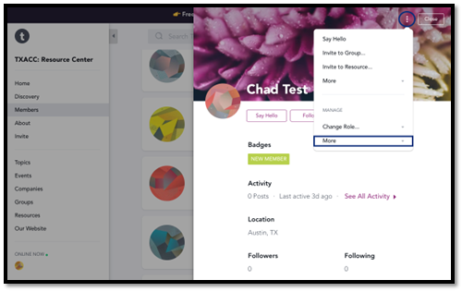

1. Click remove member and then a popup will display. If you are sure you would like to remove this member, select the “Remove this member” option. If you would like to ban this member from ever joining again, you can select the “Ban This Member” button.

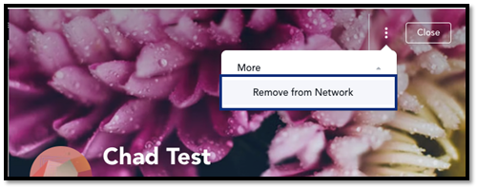

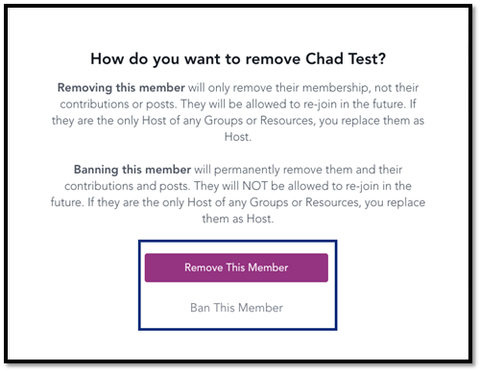

1. Refresh the page and look through the “Member” tab to confirm their removement from the network.

# How to remove a user from the Mighty Network – 2

1. Navigate to the TXACC Mighty Network Home page: <https://txacc-resource.mn.co/feed>
2. Select the “Members tab on the left-hand size of the screen to view all the members in the network.



1. Hover over the user who you would like to remove and click on the three dots on the right side of the box. Then click “More” under the “Manage” section

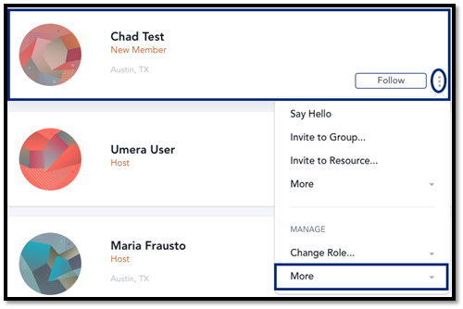

1. Then click on “Remove from Network”. A popup will display and it will ask if you would like to “Remove This Member” or “Ban This Member.” The descriptions of both options are shown in the popup

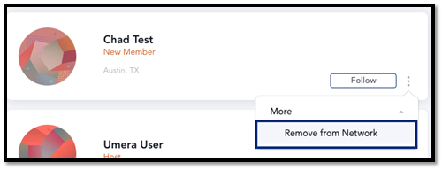



1. Refresh the page and look through the “Member” tab to confirm their removement from the network.

## Our Recommendation

* We recommend removing members through the first way shown in this document. By clicking on the person’s name and viewing their profile, you minimize the risk of removing or banning someone else that has a similar name to the individual who you are actually trying to remove.

# How to edit User Profile

1. Navigate to the Mighty Networks home

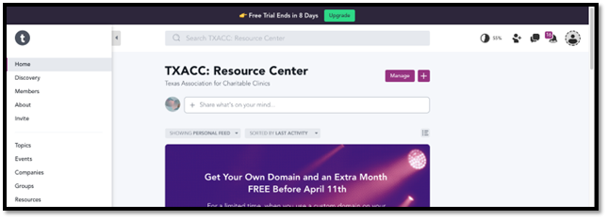

1. Click the profile icon in the top right



1. Next, click on “Personal Settings” on the drop down window

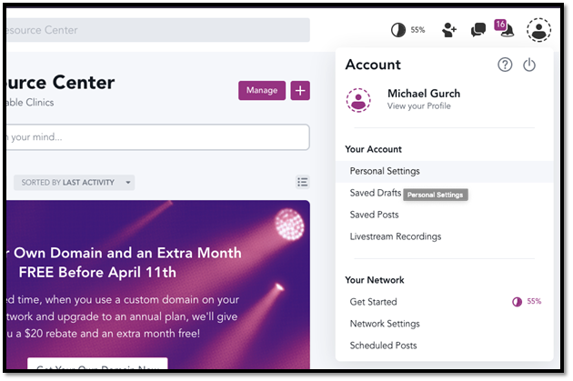

1. Click on “Edit Profile”

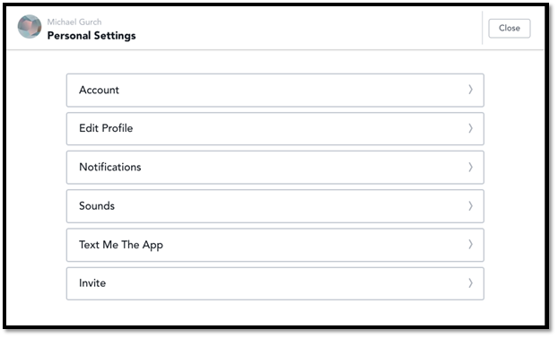

1. You should now see your profile info and can begin editing!
   1. NOTE: Don’t forget to click save on the top right after!

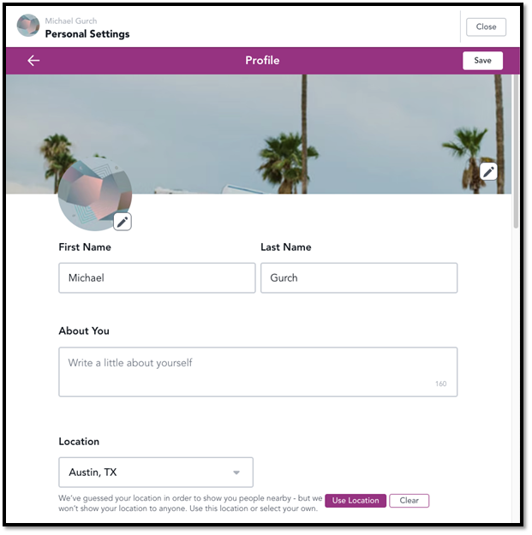

# How to upload file(s)

1. Navigate to the Mighty Networks home



1. Click on resources on the bottom left of the nav bar

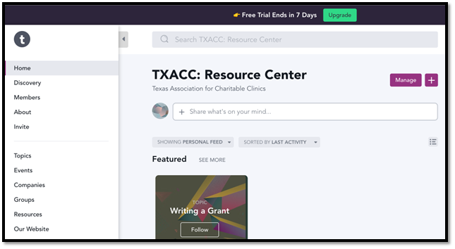

1. Click on the Resource category you wish to upload a file to

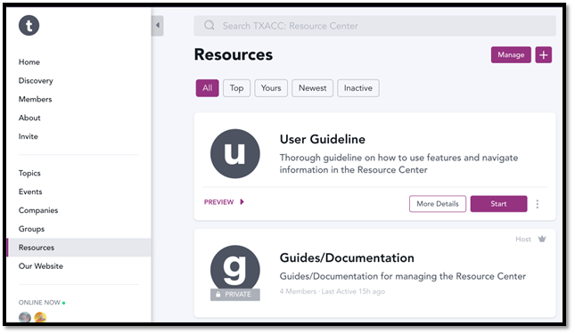

1. Add the file in the resource center. There are 2 possible locations you can add it
   1. If you want to put it under a section, go the section and the very bottom click on “Add File”

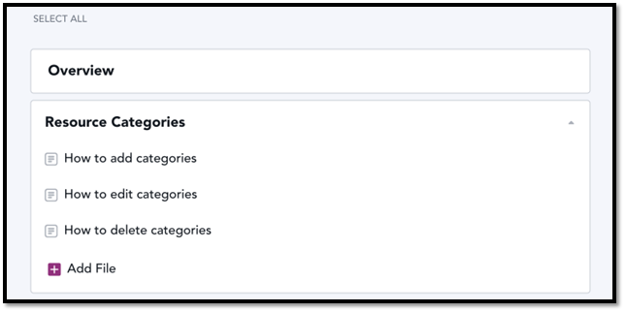

* 1. If you want to upload it under no section, scroll to the very bottom of the page and click on “Add File”

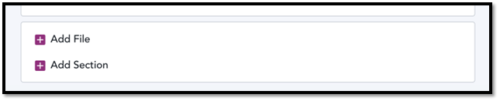

1. You should now see this “New File” pop up where you clicked to “Add File”
   1. NOTE: Don’t forget to click save on the top right after

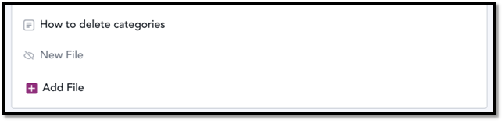

1. Click on Edit

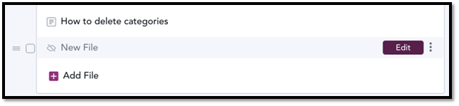

1. Next click on the “Start writing…” part until the blinking cursor appears, and then click on the “+” that appears on the left



1. Click on “Photo, Video, File”



1. Name the file

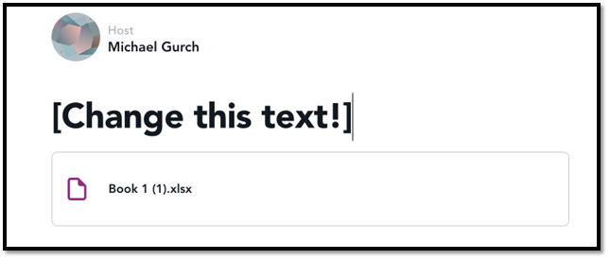

1. Next, click on “Save” on the top right

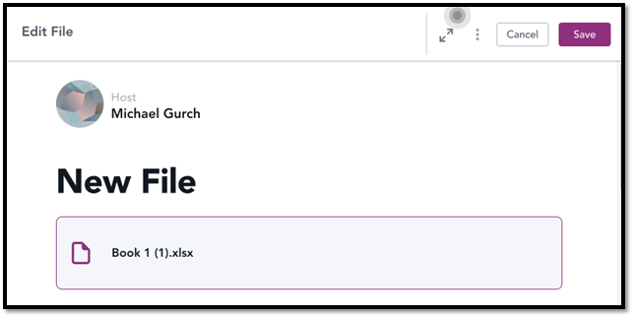

1. Next, you need to make the file visible (If you want it to be seen by others). Click on “Manage File Settings”

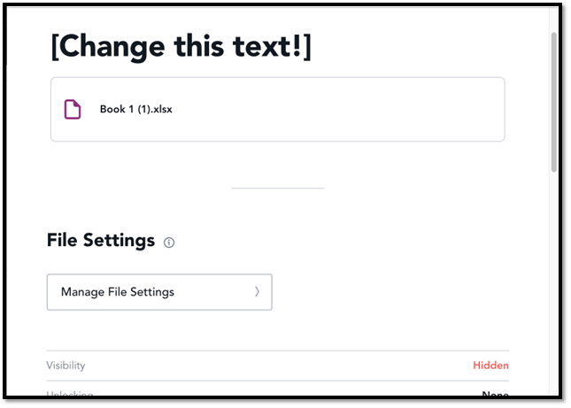

1. Click on the hidden button to switch to “visible” so the file is public/visible

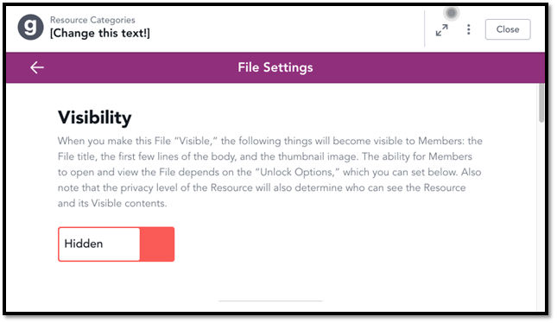

1. Choose whether to Notify members or not

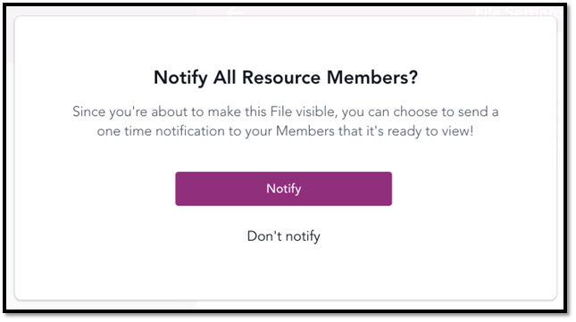

1. Lastly click close in the top right and you’re done!

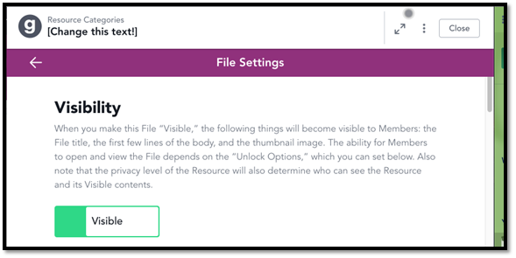

# How the File(s) upload process works

1. Navigate to the Mighty Networks home



1. Click on resources on the bottom left of the nav bar



1. Click on the Resource category where the file upload will happen



1. Click on the Chat on the bottom left

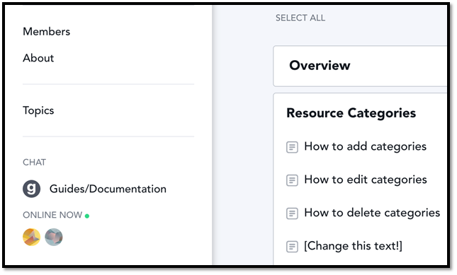

1. You should see files uploaded by clinic members and with a reason or direction on where to post the file

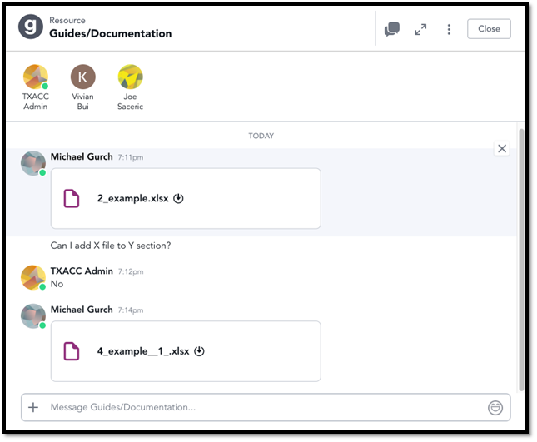

1. You can now either Approve or Reject the file
   1. To Approve, simple reply and type @[insert user’s name here], your request to upload [insert file name] has been approved

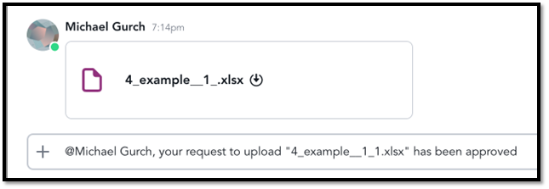

* 1. To Reject, simply delete the file by hovering on the top right side and click Delete

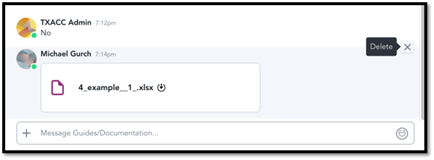

# How to create a Group

1. Navigate to the TXACC Resource Center Home: <https://txacc-resource.mn.co/feed>
2. Select “Groups” on the left-hand side of the screen

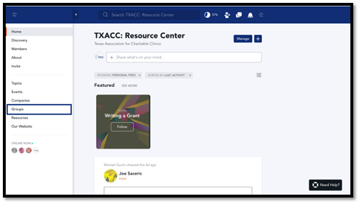

1. Once inside of the “Groups” tab, click on the “+” button on top right of the screen.

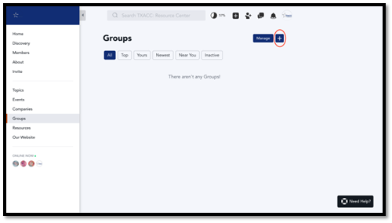

1. After clicking on the “+” sign, you will see a screen that “The Big Stuff.” Enter in the name of group under “Group Title”. You can also add a group tagline and a group description if needed. Finally, select “Privacy” as "Private”. Most groups that TXACC plans to make will be private. You can make the groups “Public” or “Secret” as well. Once you have selected everything, click on “Finish” located at the top-right of the screen.

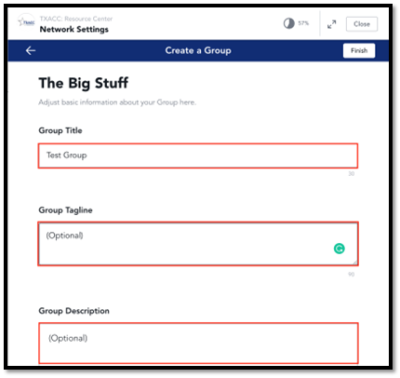

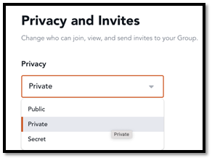

1. After you click “Finish”, click “Close” on the top right of the screen. The group you created should show up at the top of the screen.

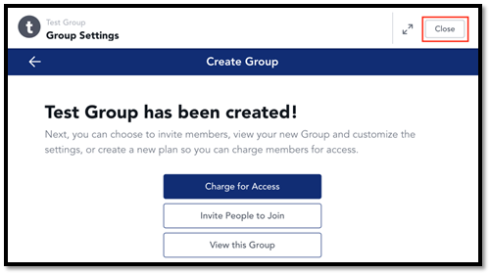

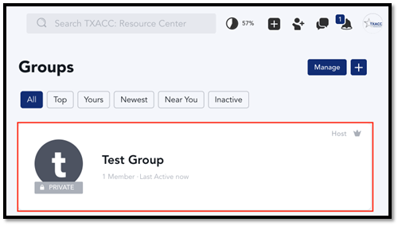

# How to enable the Chat feature inside of the Group

1. Click on the Group that you would like to enable the Chat feature for.
2. Once you are inside of the group, click on the “Manage” button on the top-right side of the screen. The click on “General Settings.”

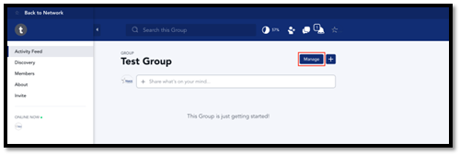

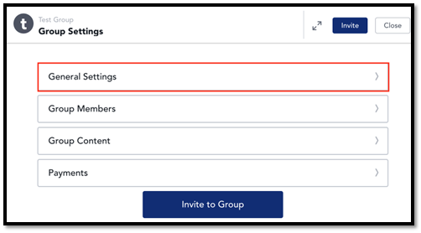

1. Scroll down to “The Small Stuff” heading. Under this heading, you will see “All Member Chat.” Toggle the “All Member Chat” to on. The click “Save” at the top right corner. Then hit “Close” at the top right above the “Save” button.

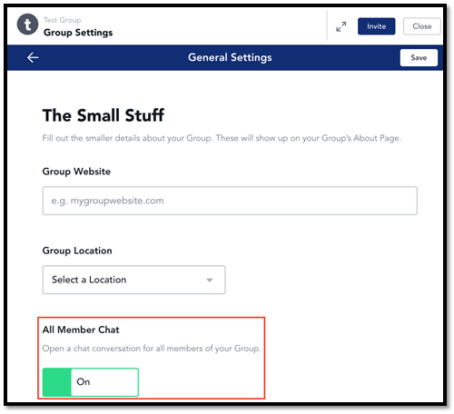

1. You should see the Chat appear on the left-side of the screen. Click on the chat to open up the window.

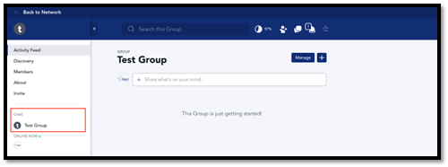

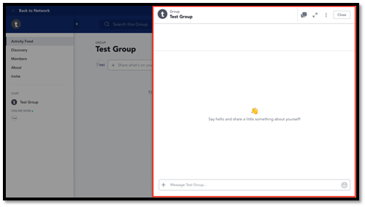

## How to edit groups

1. Navigate to the [TXACC Mighty Networks home](https://network-7329457.mn.co/feed)
2. Click on “Groups”

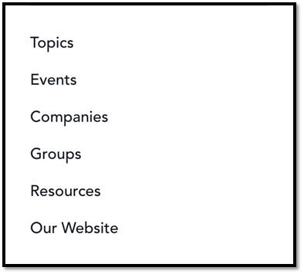

1. Click on the “Group” you want to edit

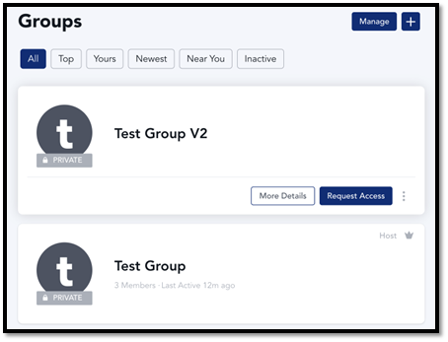

1. Next, click on “Manage”

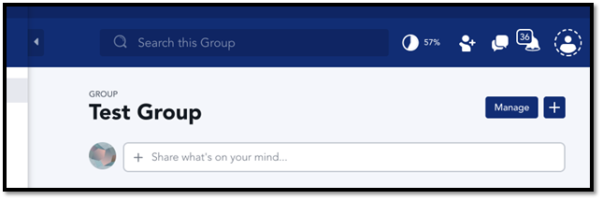

1. Here you can change a few things including the “General Settings”, “Group Members”, and “Group Content”

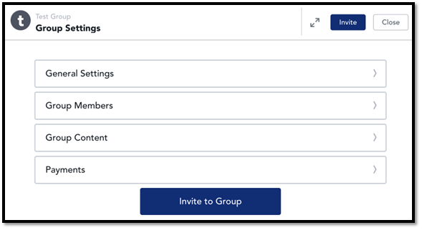

1. In “General Settings”, you can modify
   1. Group Title
   2. Group Tagline
   3. Group Description
   4. Group Website (you can add a link to another website)
   5. Group Location
   6. Group Branding
   7. Privacy level
   8. Invites (modify who can invite who)
   9. NOTE: the one setting you want to change is the “Invites”
      1. Change this to “Only Host and Moderator can invite”

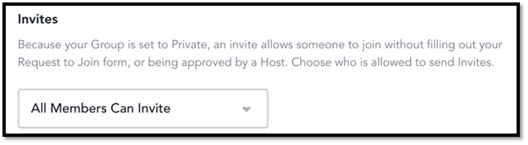

1. Next, you can check the “Group Members” settings

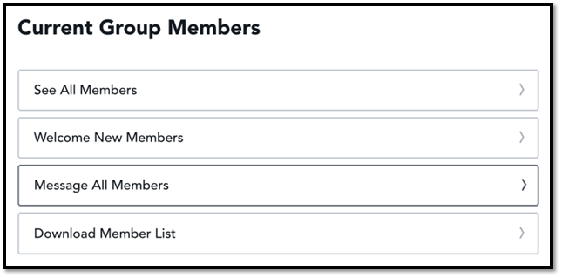

1. Next, you can modify “Group Content”
   1. Quick Posts
   2. Articles
   3. Polls and Questions
   4. Events
   5. Topics
   6. Welcome Section
   7. Featured Section

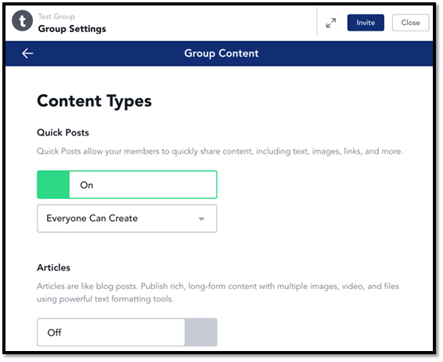

1. Note, remember to “Save” your settings!

# How to delete a Group

1. Navigate to the TXACC Resource Center Homepage: <https://txacc-resource.mn.co/feed>
2. Select “Groups” on the left-hand side of the screen

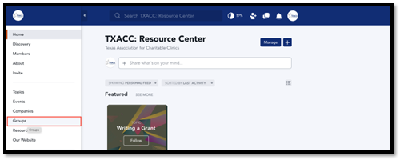

1. Find the name of the group you would like to delete and hover over it. The select three dots on the right side of the group and select "Delete.”

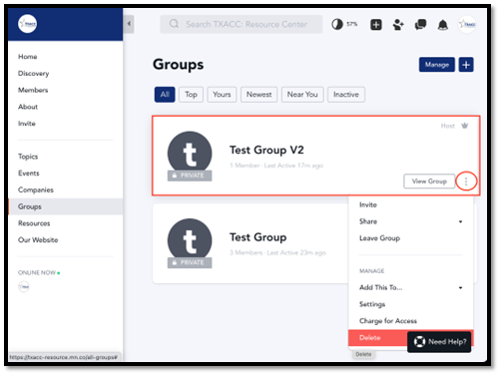

1. Once you click “Delete”, a popup will appear. If you are sure you would like to delete it, then select “Yes, Delete.”

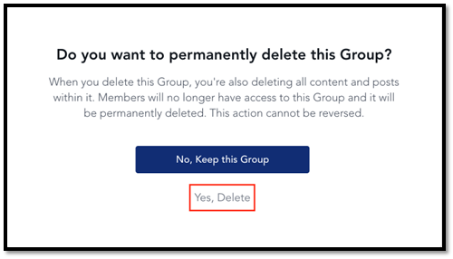

# How to add users to the Group Chat

1. Navigate to the TXACC Resource Center Homepage: <https://txacc-resource.mn.co/feed>
2. Select the “Groups” tab on the left-hand side of the screen.



1. Select the name of the Group of that you would like to add members to.



1. Select the “Members” tab on the left-hand side of the screen. On the following screen, select the “Invite” option.

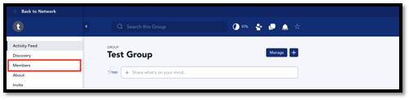

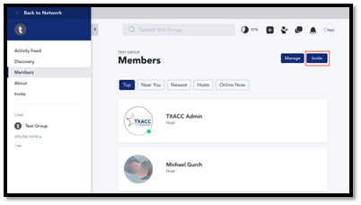

1. Once you’re at the invite screen, type the “@”, followed by the name of the individual in the TXACC Resource Center. Use the picture below as an example of the format. This “@” mention feature will only work if the individual is a part of the main network. As a reminder, most individuals in a group should have the “Member” role. Hit "Send” when you have added all the members you’d like.

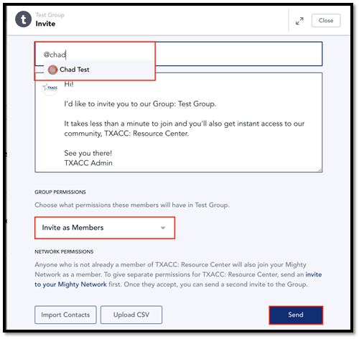

## How to search for group chats

### Method 1

1. Navigate to the [TXACC Mighty Networks home](https://network-7329457.mn.co/feed)
2. On the top right of the screen, click the chat icon

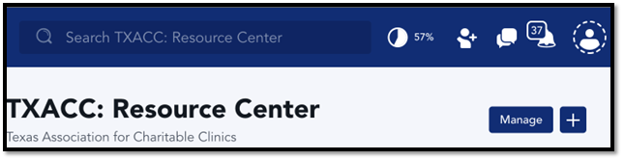

1. You should now see the chats you are in. You can search for the chat via the search bar

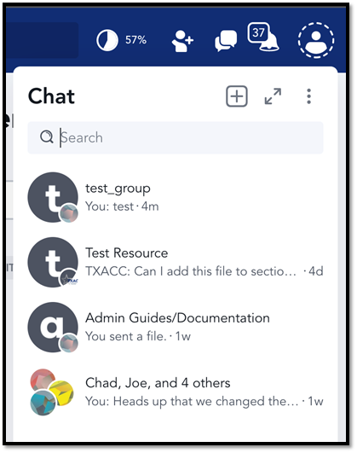

### Method 2

1. Navigate to the [TXACC Mighty Networks home](https://network-7329457.mn.co/feed)
2. Search for a group via the search bar at the top of the homepage

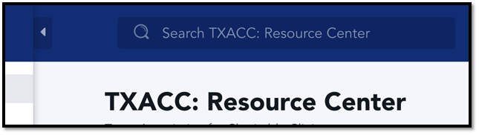

1. You should now see the group you searched. Click it
   1. Also note you can filter to just groups by clicking “Groups”

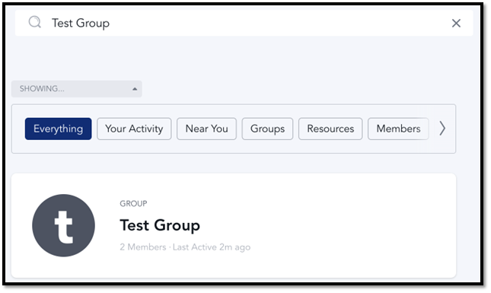

1. Next look on the bottom left of the left pane and click on the Group Chat

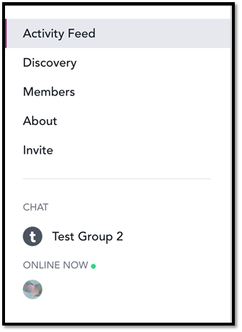

1. Have fun chatting J

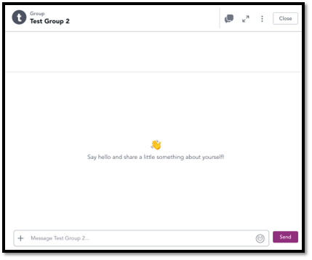

### Method 3 (To just see the groups you are in)

1. Navigate to the [TXACC Mighty Networks home](https://network-7329457.mn.co/feed)
2. Click “Groups” on the left pane near the bottom

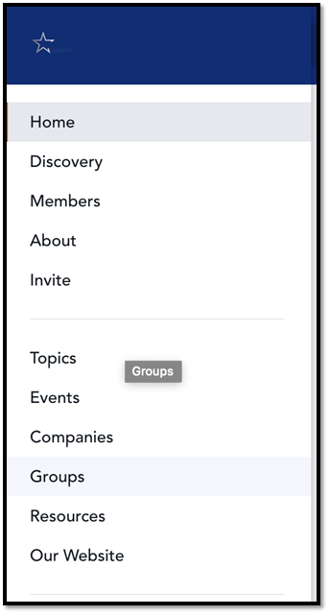

1. Next, to just see the groups you’re in, click the “Yours” filter

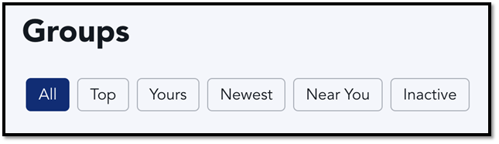

1. You should now see the groups you are. Click the one you want to chat in

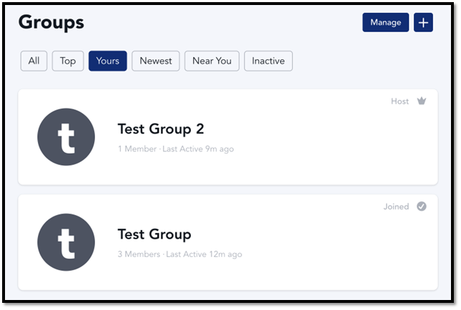

1. Next look on the bottom left of the left pane and click on the Group Chat



1. Have fun chatting J



## How to start Direct Message (DM) chat

1. Navigate to the [TXACC Mighty Networks home](https://network-7329457.mn.co/feed)
2. On the top right of the screen, click the chat icon

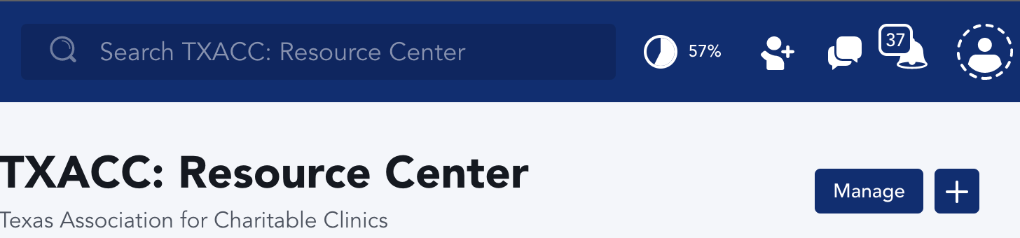

1. You should now see the chats you are in. To start a DM chat, click on the “+” on the top right.

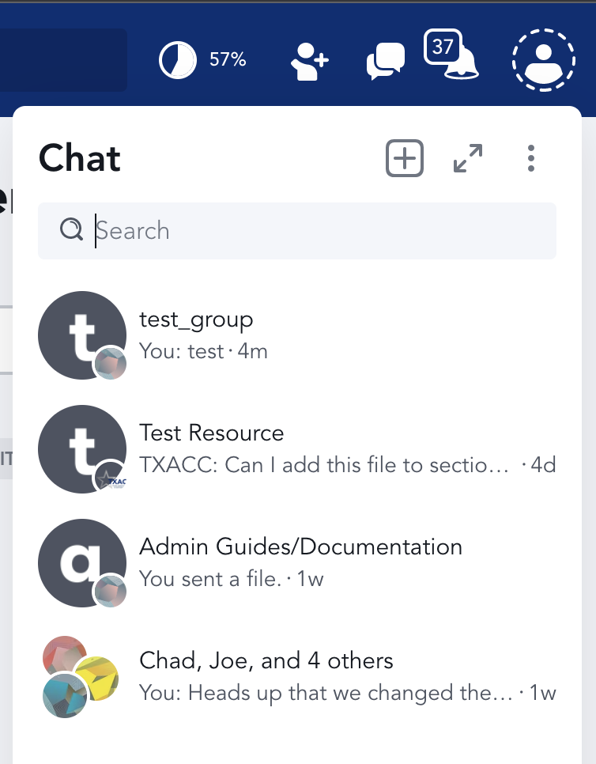

1. Now invite a person or people into the chat via searching or checking the box of the people shown below

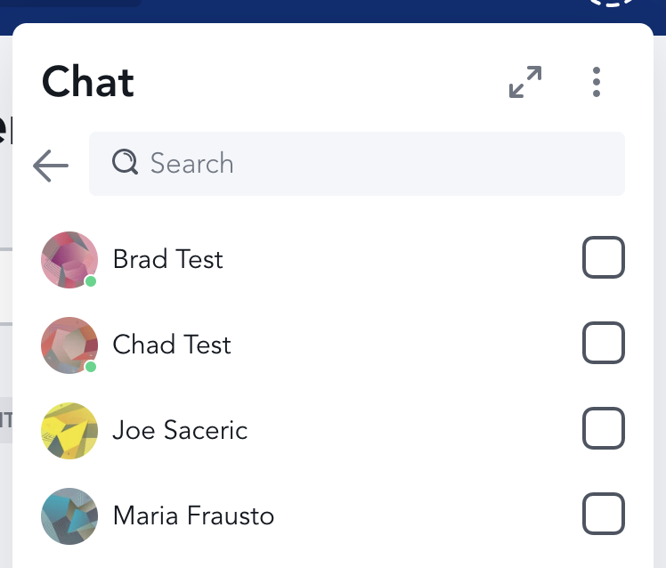

1. Lastly, after adding the people, click start chat

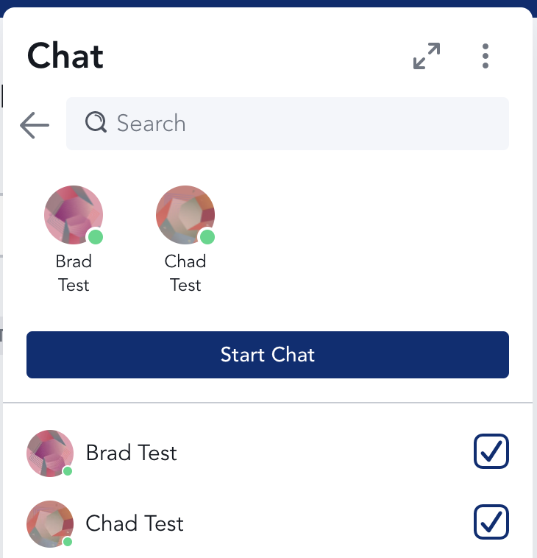

1. Have fun chatting! J

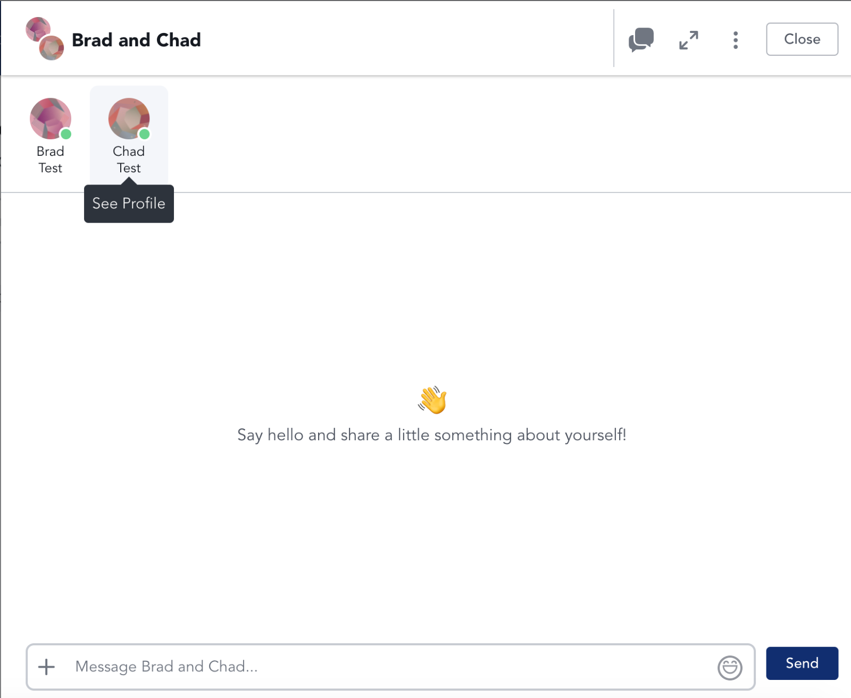

## How to attach files to chat

1. Navigate to chat you want to attach a file to
2. Click on the “+” on the bottom left

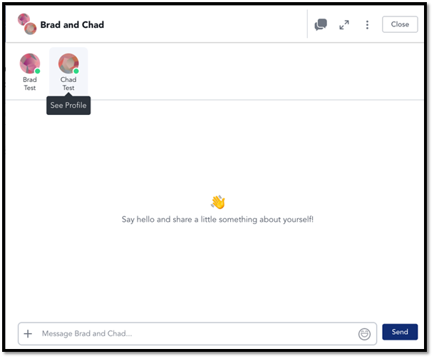

1. Click “Attach File”

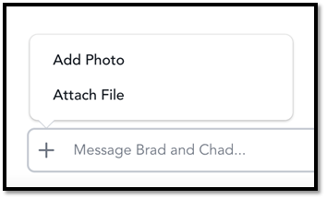

## How to filter Resources

1. Navigate to the [TXACC Mighty Network](https://txacc-resource.mn.co/feed)
2. Click on “Resources” on the left pane

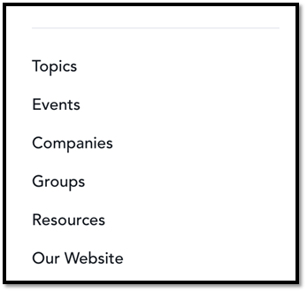

1. You can search and filter by the boxes near the top

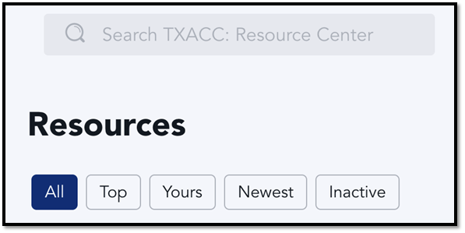

## How to search for Resources via search bar

1. Navigate to the [TXACC Mighty Network](https://txacc-resource.mn.co/feed)
2. There should be a search bar at the top. Type in the name of the resource category you want to search for

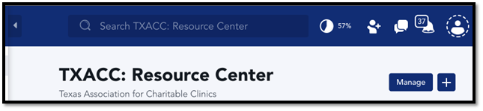

1. Click on the resource category you want to access

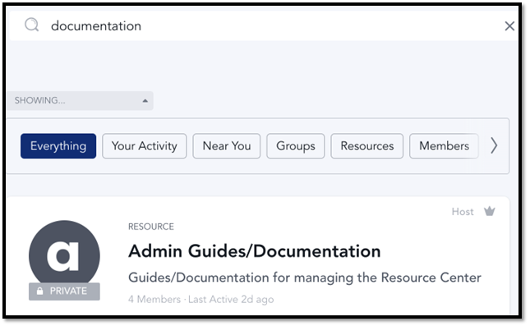

# To search for files

1. There should be another search bar at the top. You can search for files/resources here.

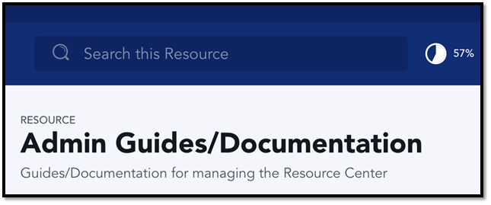

1. Here’s an example of searching for “Add files”:

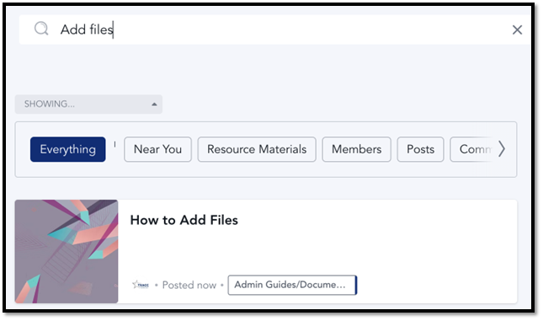

# How to Search for Clinics and their Members in the Resource Center

1. Navigate to the TXACC Resource Center Homepage: <https://txacc-resource.mn.co/feed>
2. Select the “Companies” tab on the left-hand side of the screen

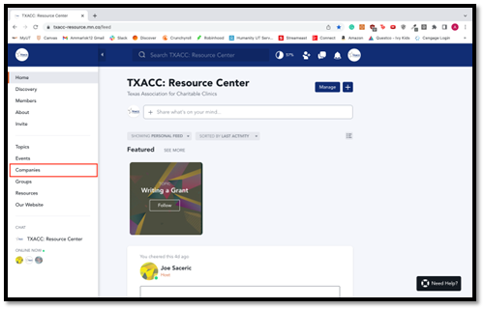

1. Once inside of the “Companies”, you will see all of the clinics that all members are a part of. Go the search bar located at the top of the screen and type in the name of the clinic that you are looking for.

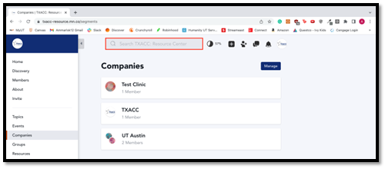

1. When you type in the name of the clinic, you will see some search results appear below, as well as a section to filter you search results. Click through the filters and find the “Companies” filter to narrow your search down.

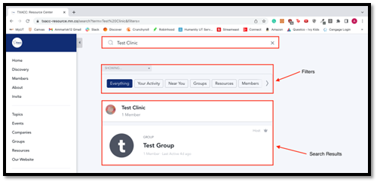

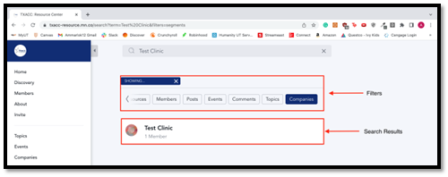

1. Once you have narrowed your search results, click on the name of the clinic to see which members are a part of the clinic.

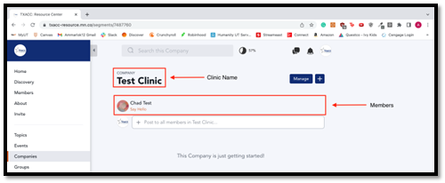

# How to send Mass Announcements for the Resource Center

### Method 1 – Create a post on the home page (also can do this in Groups! – same steps)

1. Navigate to the [TXACC Resource Center](https://txacc-resource.mn.co/feed)

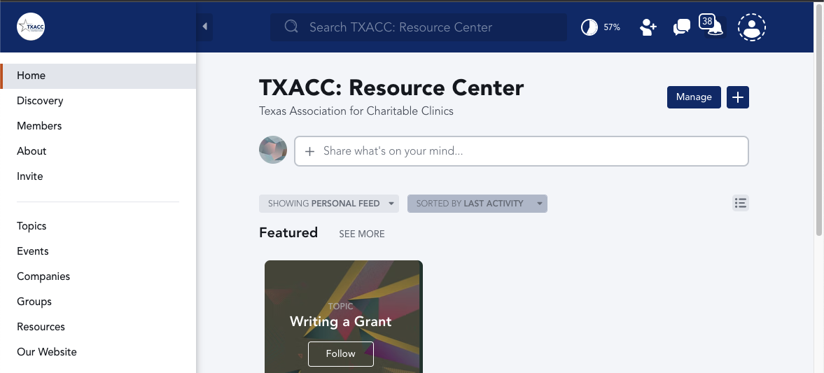

1. Click on “Share what’s on your mind…”



1. Type the mass announcement you want to send

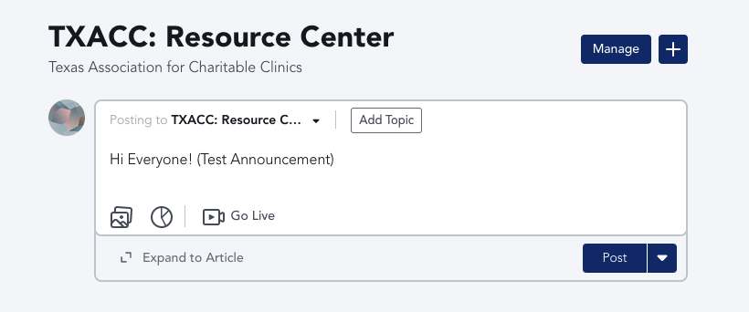

1. NOTE: make sure “Posting to” is set to “TXACC: Resource Center”. Then click “Post”
   1. Optional – You can also add a topic if you want!

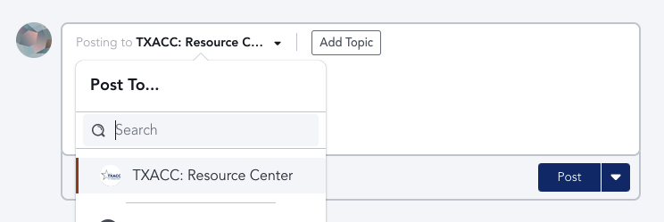

1. Next you will get a popup asking to add a Topic. Click “Post”
   1. NOTE: You can also post in a topic and it will still notify everyone

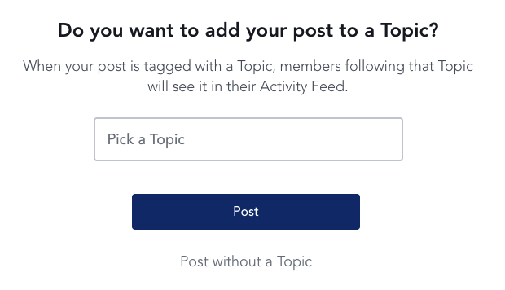

1. You’ll get another popup, and you’ll want to click “Notify”

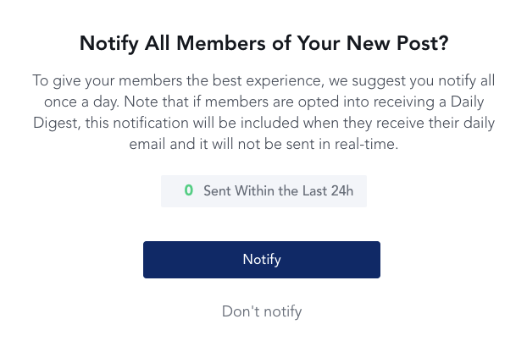

1. NOTE: It works the exact same in Groups!

### Method 2 – Create an article on the home page

1. Navigate to the [TXACC Resource Center](https://txacc-resource.mn.co/feed)



1. Click on “Share what’s on your mind…”



1. Next, click on “Expand to Article”

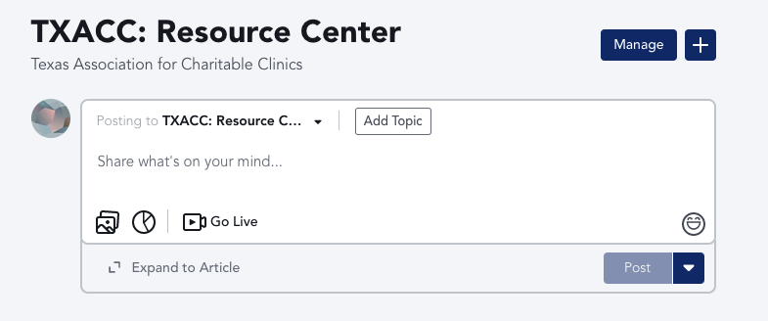

1. Add a title to the Article, and you can type/add content where it says “Share something amazing”

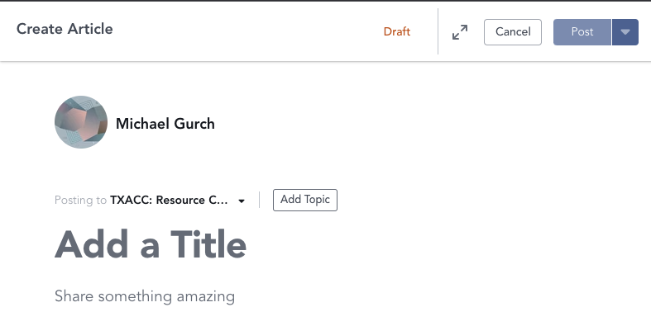

1. If you click the “+” symbol, you can also add files/links or even bulleted lists for your announcement



1. After you’re done creating the article, click “Post”

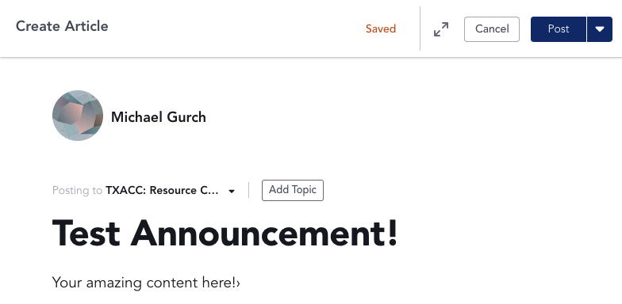

1. Next you will get a popup asking to add a Topic. Click “Post”
   1. NOTE: You can also post in a topic and it will still notify everyone



1. You’ll get another popup, and you’ll want to click “Notify”



### Method 3 – Mass Message people on Mighty Networks Chat (also can do this in Resources! – same steps)

1. Navigate to the [TXACC Resource Center](https://txacc-resource.mn.co/feed)



1. Click on “Share what’s on your mind…”

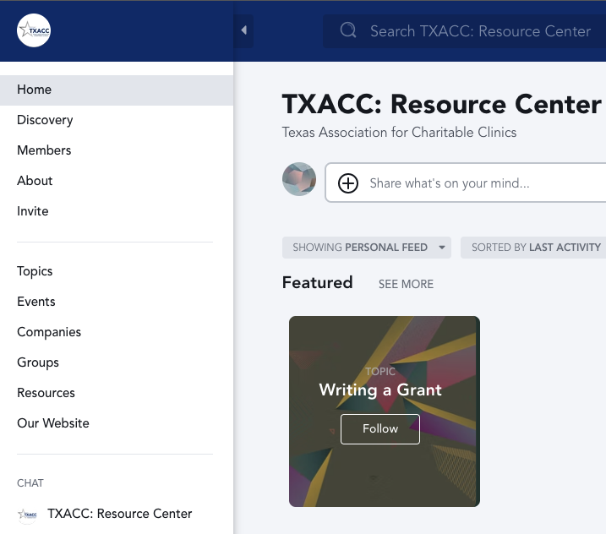

1. Type your message in the chat, and just click send!

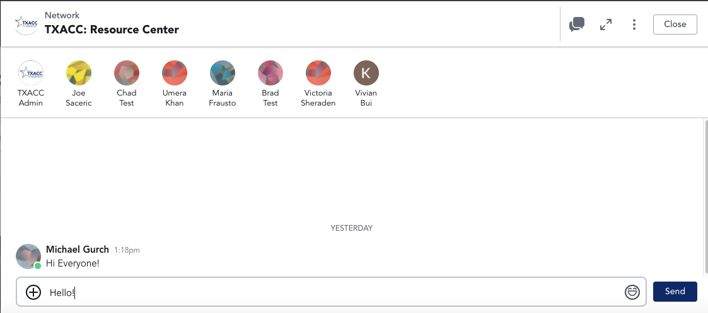

# How to manage your notification preferences

1. Navigate to the TXACC: Resource Center Homepage: <https://txacc-resource.mn.co/feed>
2. Select the notification bell at the top right of the screen

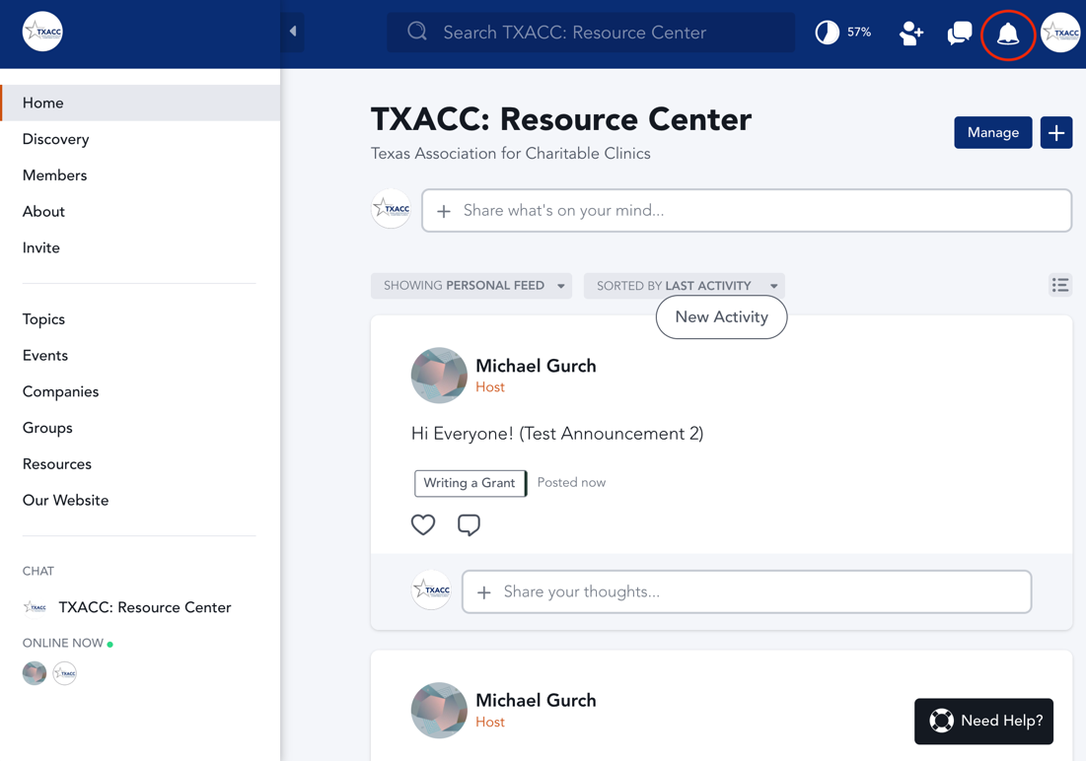

1. In this window, you will see all of your notifications. Click on the Settings Gear Icon at top of the window to open your notification settings.

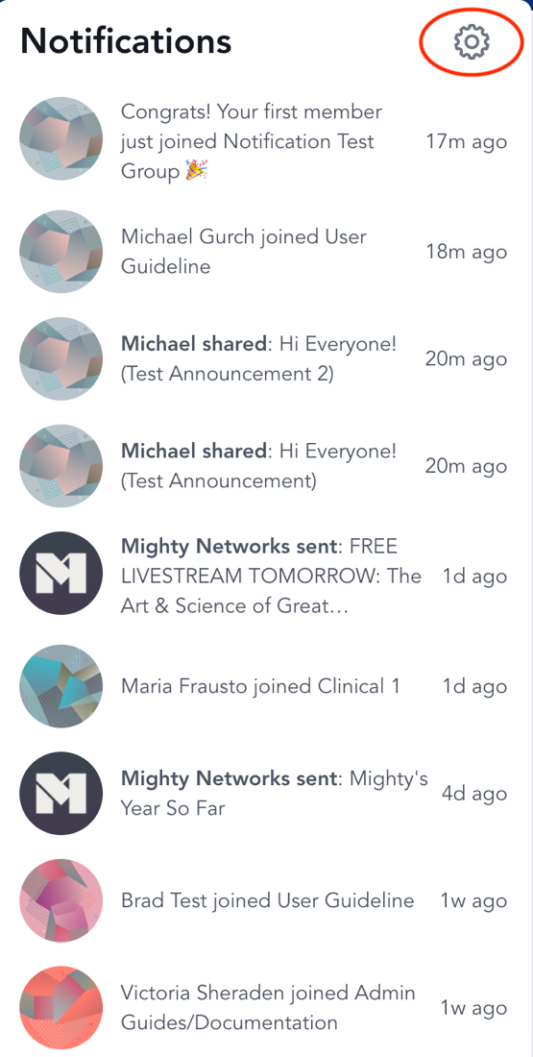

1. In this window, you will see a list of notification settings that can be turned on and off. We recommend having email notifications and mobile notifications on. We also recommend the “Daily Digest” option for Email Frequency so that your inbox is not flooded with messages.

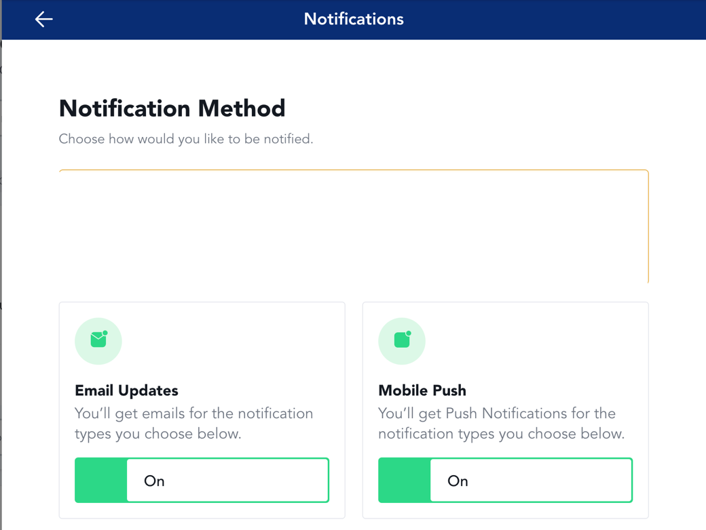

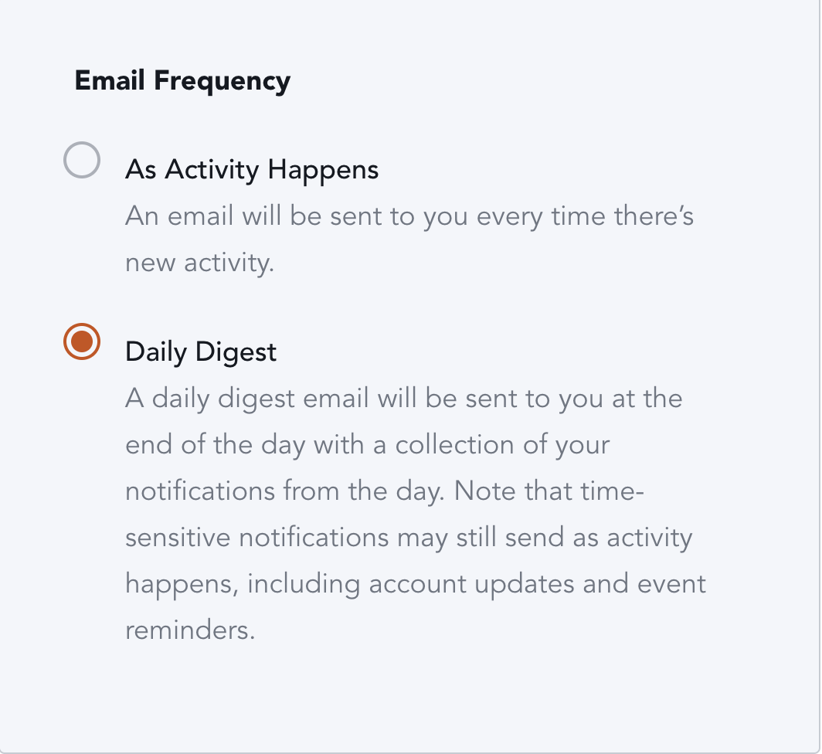

1. For the “Notification Types” section, most of these will be on and we recommend leaving them on so you are updated on the activity of the resource center

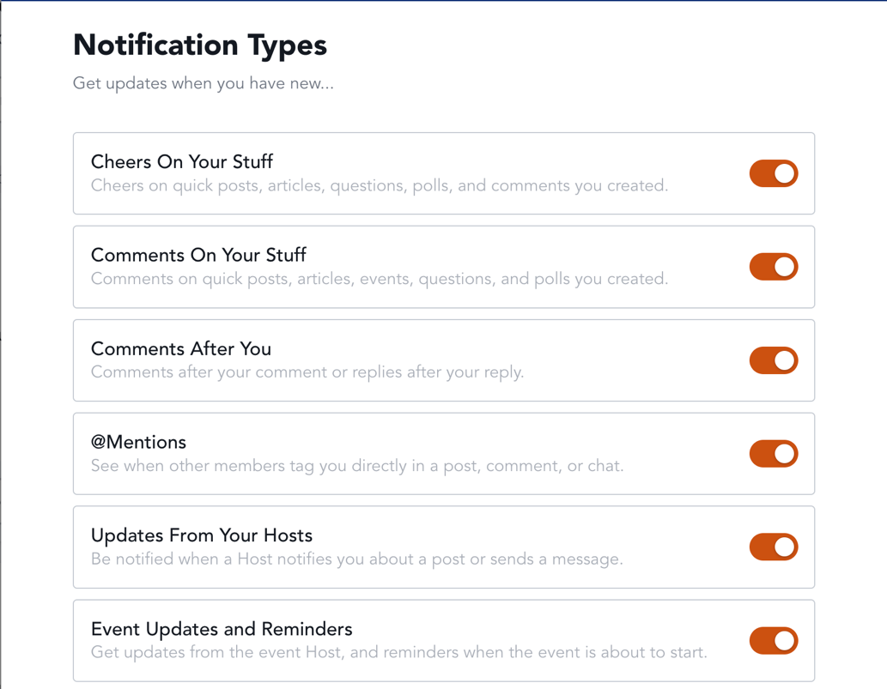

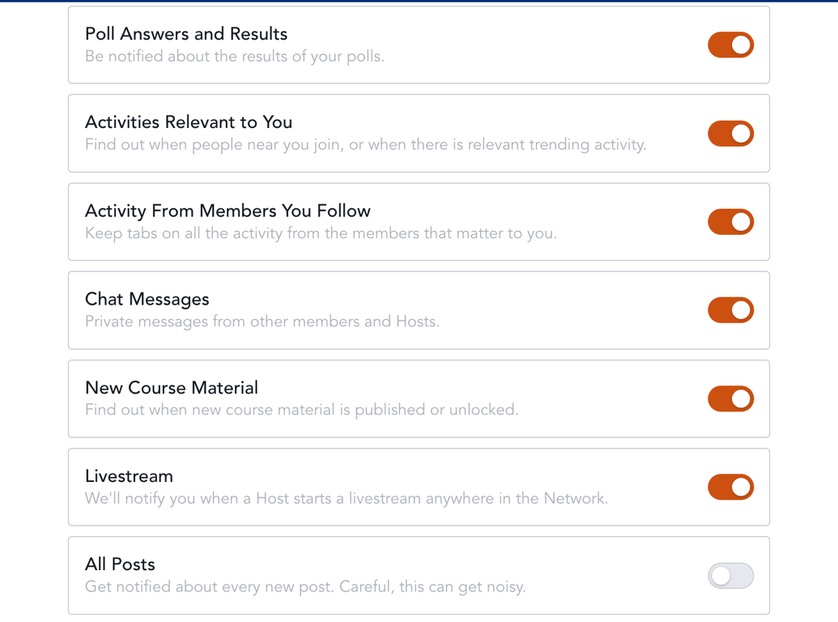

1. For the “Group and Resource Notifications” section, we recommend having these notifications on as well. You will only see the Groups and Resources that you have access to.

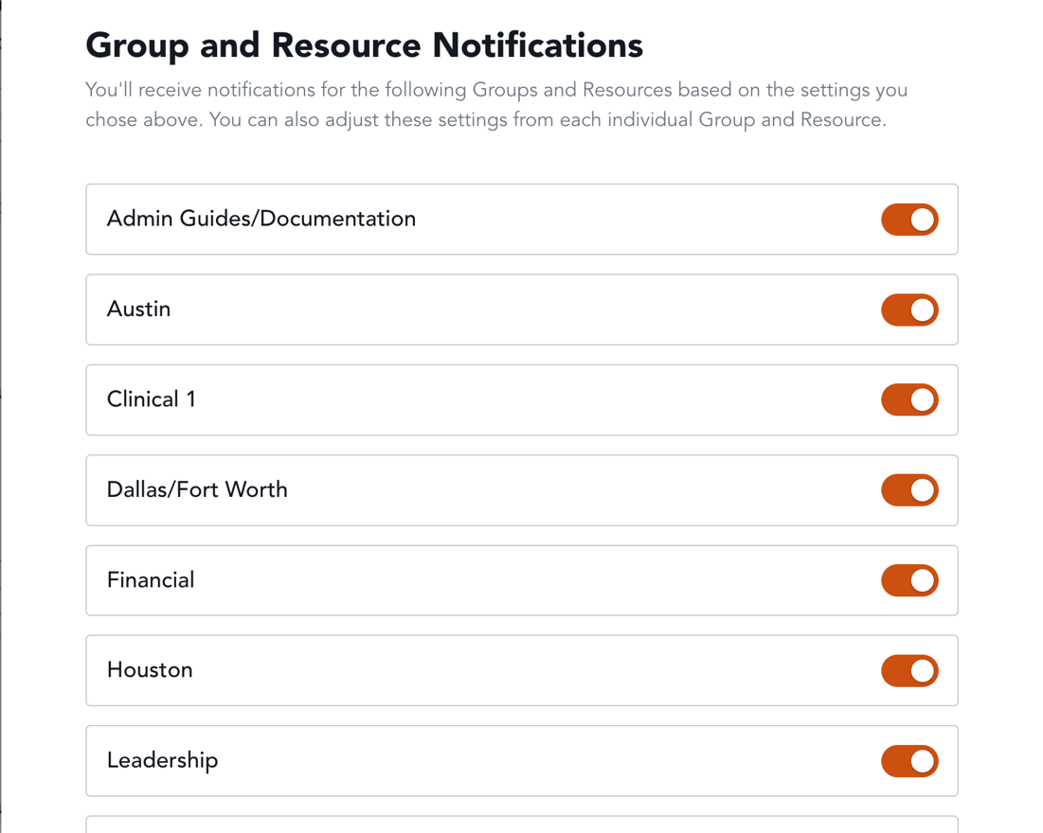

# How to create IT Questions

1. Navigate to the [TXACC Resource Center](https://txacc-resource.mn.co/feed)

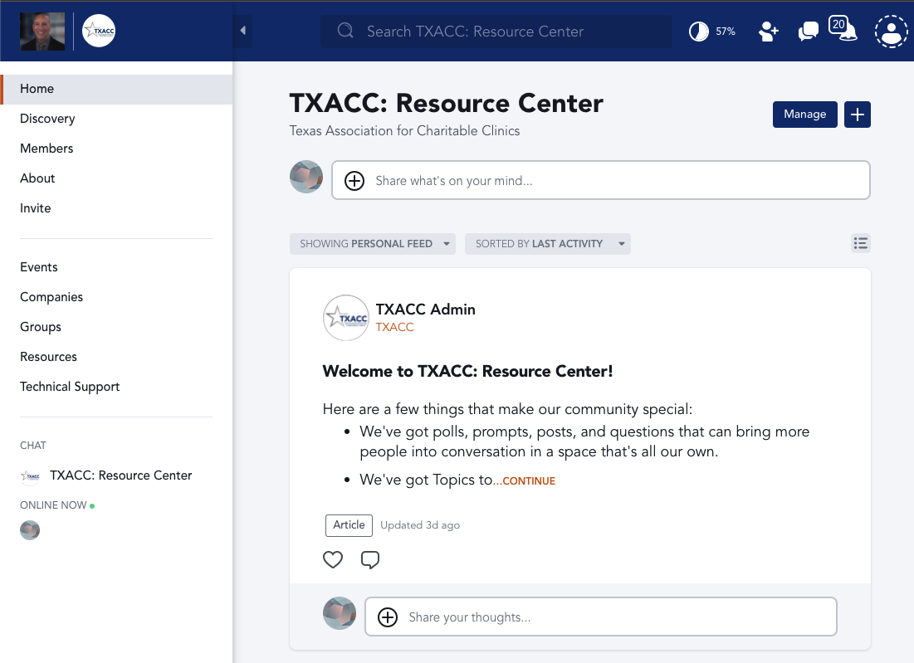

1. Next, click on “Technical Support” on the left nav bar

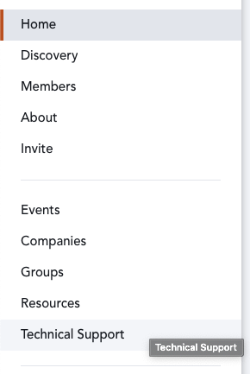

1. Click on the “Share what’s on your mind…” text box and type in your question!
   1. NOTE: it’s helpful to mention one of the TXACC Admins such as “Umera Khan”
      1. You can do this by typing “@Umera Khan” and there should be a popup with her name

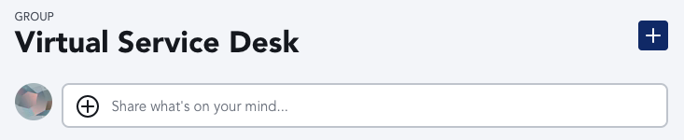

1. After you have typed in your question, simply click on “Post” on the bottom right.

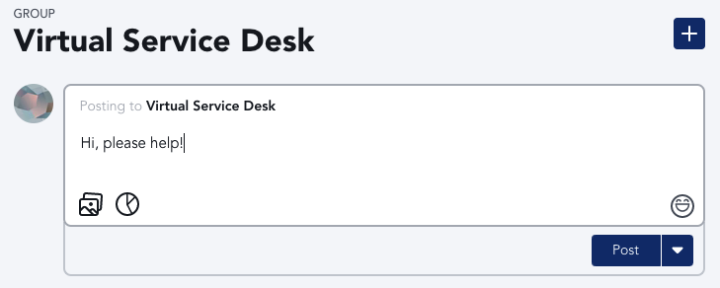

# How to access and answer IT questions

1. Navigate to the TXACC: Resource Center Homepage: <https://txacc-resource.mn.co/feed>
2. Select the “Technical Support” tab on the left-hand pane

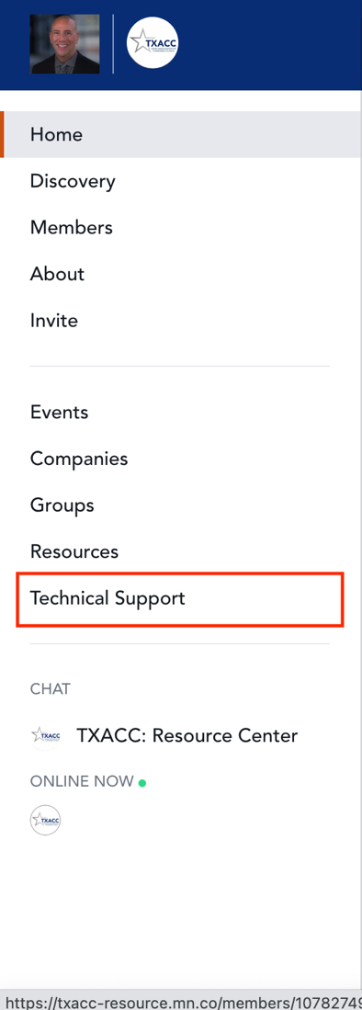

1. You will be brought to a screen that says “Virtual Service Desk”. This a group that we created in the Mighty Network, and it can also be accessed in the “Groups” tab. We placed a link for technical support so members and admin did not have to go searching for it in the groups tab.

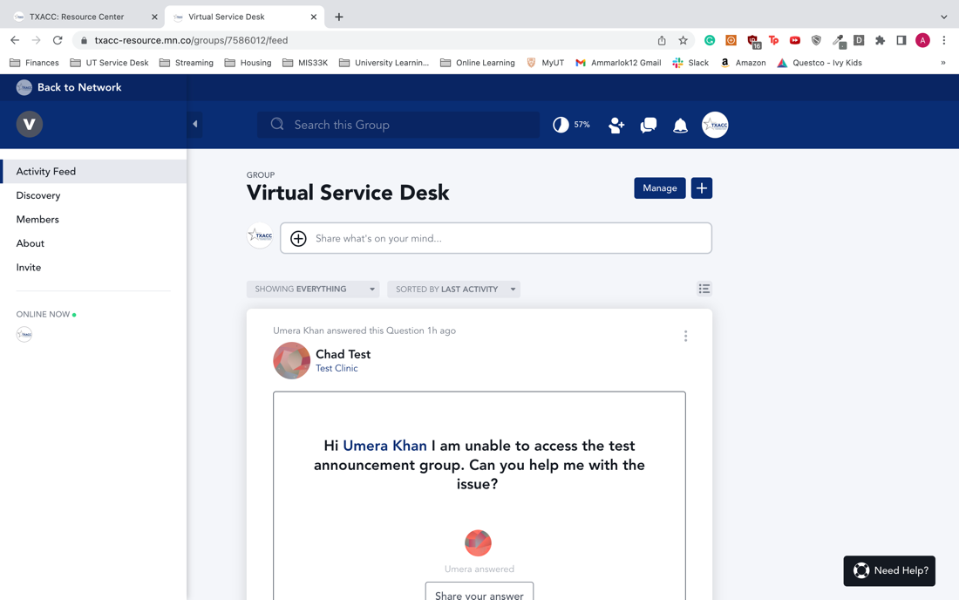

1. In this group, you will see members post questions. Under the questions, TXACC admin can respond to any IT questions posted. If you see an unanswered question, do your best to answer their question, or let them know you are working on a solution.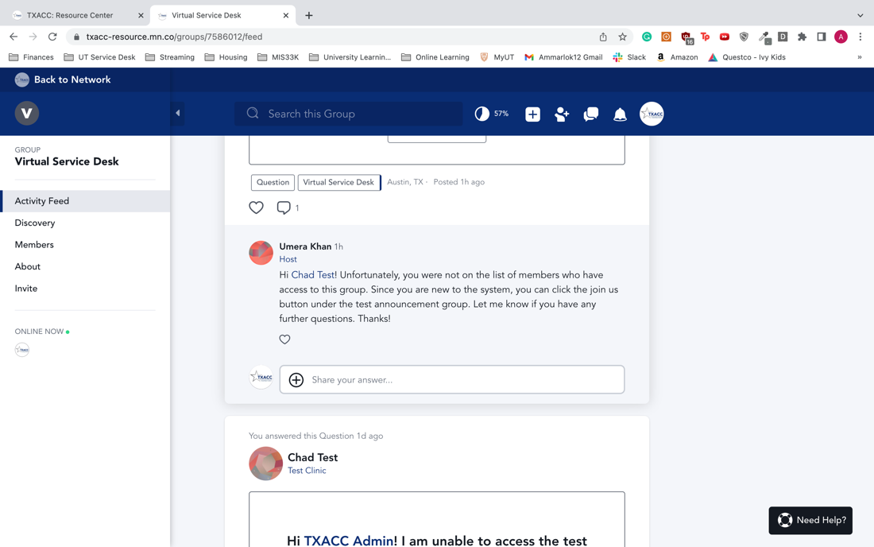

## Navigate to Network Settings

1. After logging in as an admin, at the homepage, on the top right corner, click on the avatar

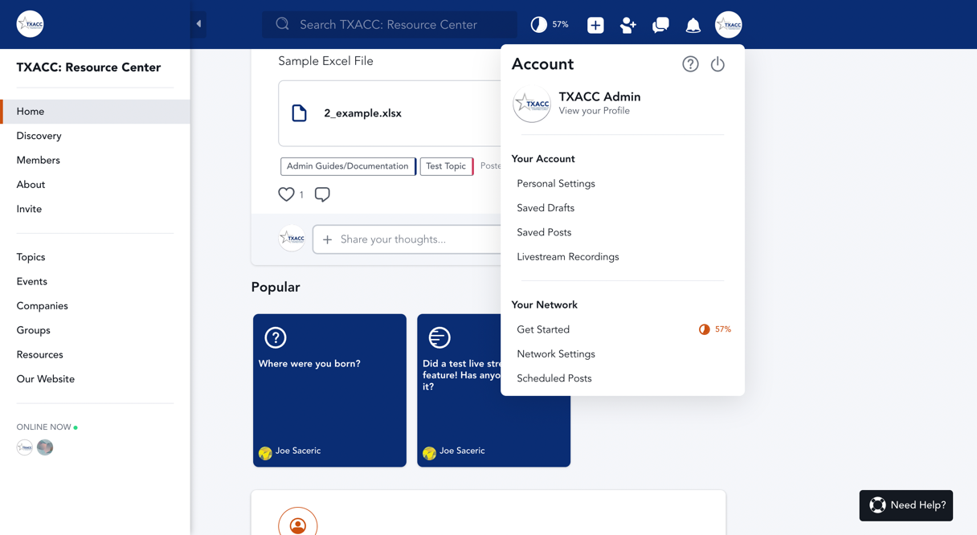

1. Navigate to Network setting

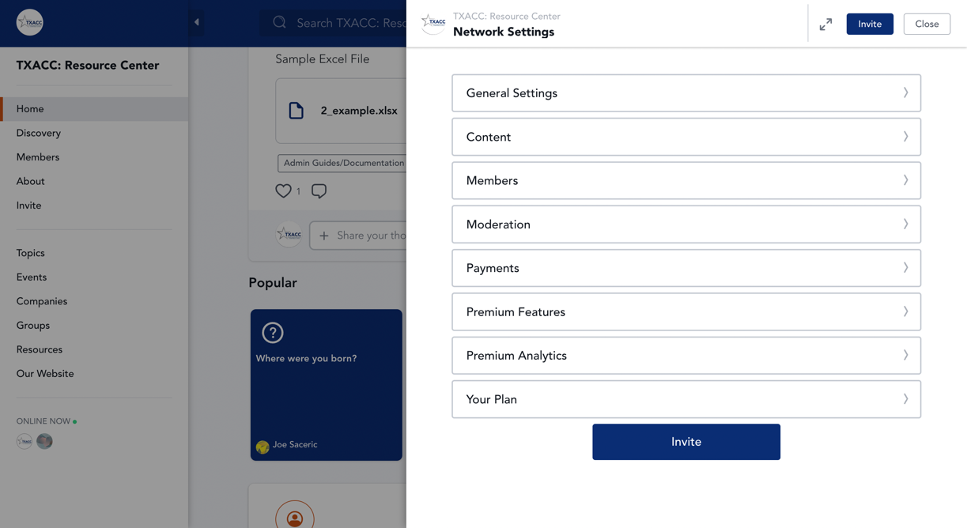

1. Click on “General Settings”

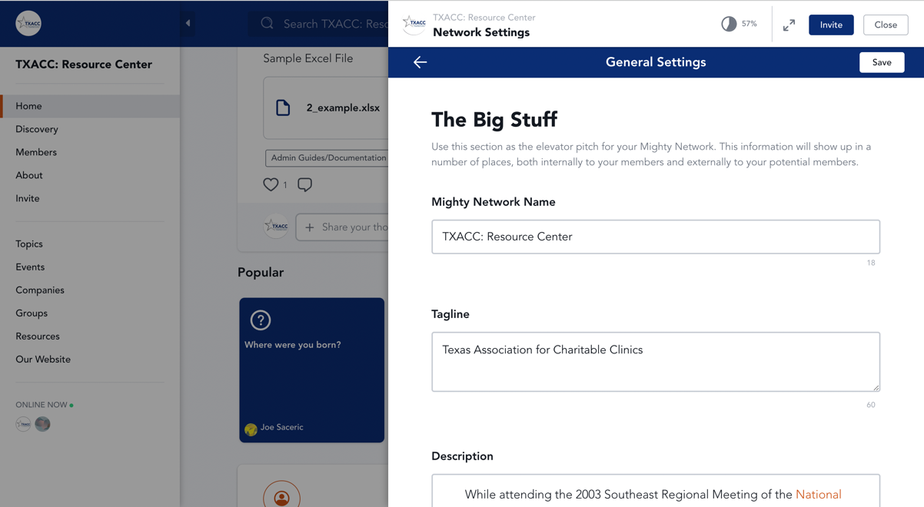

1. See the next section of this guideline to review information about the settings

## About Network Settings

Once completed the previous section ([How to get to Network Settings](bookmark://NS)): Scroll down and explore different ways to configure Mighty Network

1. **The Big Stuff**

* Mighty Network Name

NOTE: *We recommend not to change the Network Name as it will affect users’ searching result to log on to the Resource Center.*

* Tagline
* Description

1. **The Small Stuff**

NOTE: *We recommend not to change this section.*

* What are you creating
* Location
* Company Website

1. **Branding** – UI/UX Adjustment

* Network Branding
* Landing Page

1. **Domain**

NOTE: *Do not change this section.*

1. **Privacy, Search, and Invites**

NOTE: *Do not change this section.*

* Privacy
* Invites
* Search indexing

1. **Other Settings**

NOTE: *Do not change this section.*

* Category
* Goals

# Branding in Network – Network Settings

1. In Network Settings, scroll to Branding section, hit on “Manage” under Network Branding

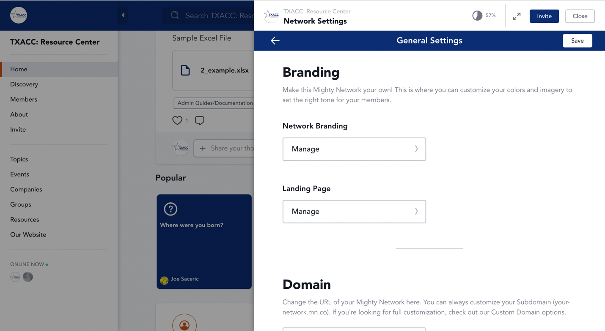

1. Review “**TXACC Branding**” (in Resources > Admin Guides/Documentation > UI/UX) to understand the colors and logo used by TXACC. In other to change the color, type in the color code number. The following example will show how to change color for the header.

TXACC Colors:

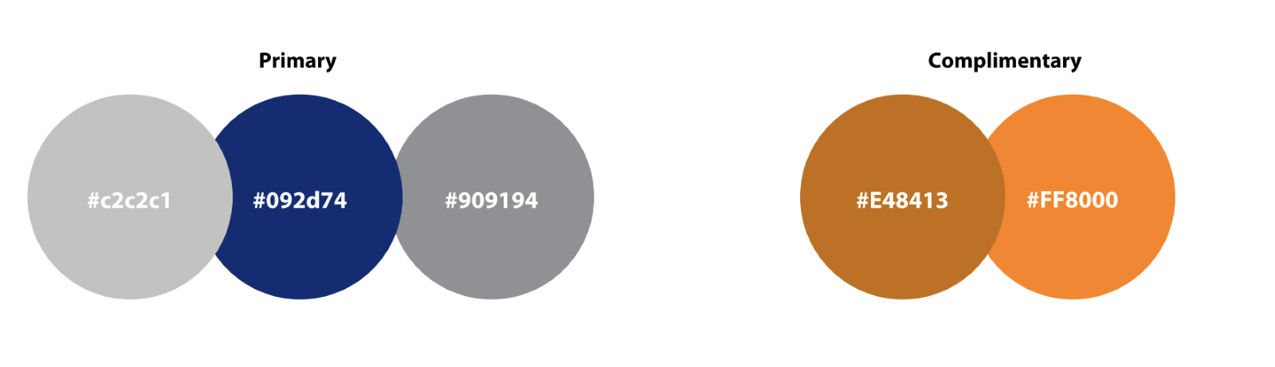

1. To change color of the header, click on the color or the code

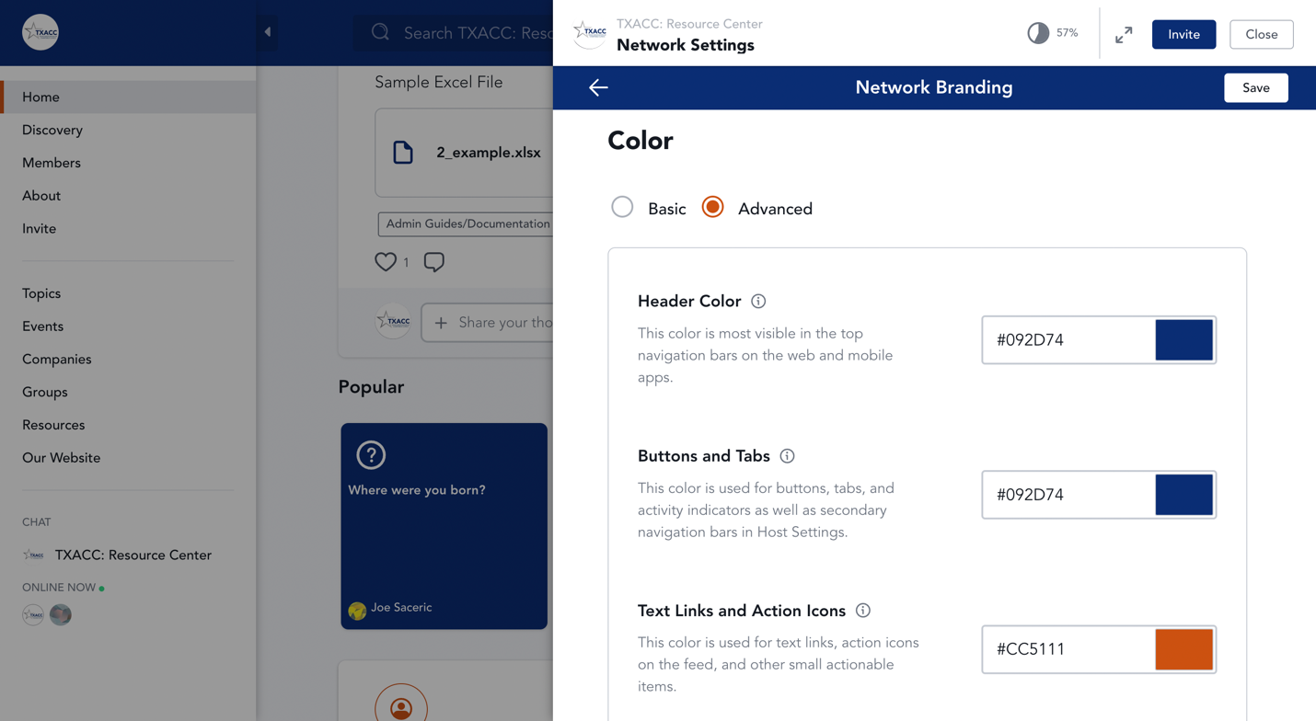

1. Next, type in TXACC’s color code that you want to change.

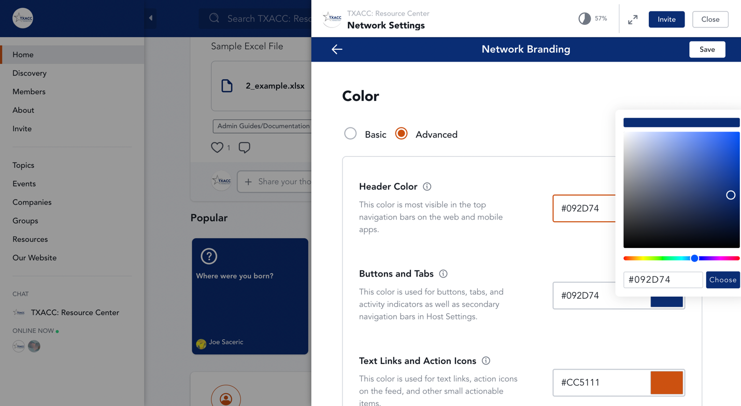

1. Click Choose > Save > Close. Change will now be visible in the Resource Center.

## Branding in Resource – Resource Settings

1. After logging in as an admin, at the homepage, navigate to Resource on the menu pane on the left-hand side.

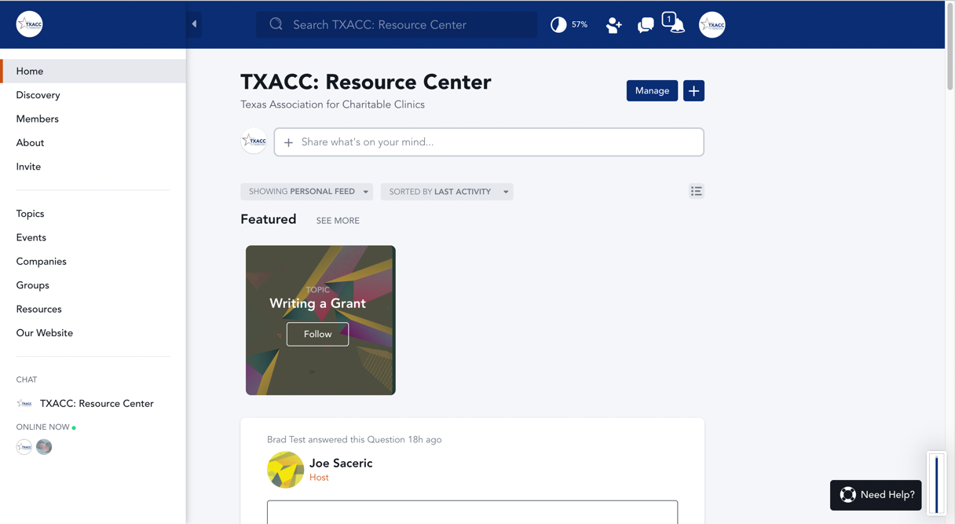

NOTE: Unlike Network Settings, the Settings for Resource will only apply to one resource only. Therefore, to make the newly created Resource complies with TXACC’s branding guidelines, you need to **make an adjustment to the branding color of the Resource every time you create a new Resource.**

1. Click on the newly created Resource or the Resource you want to make adjustment.

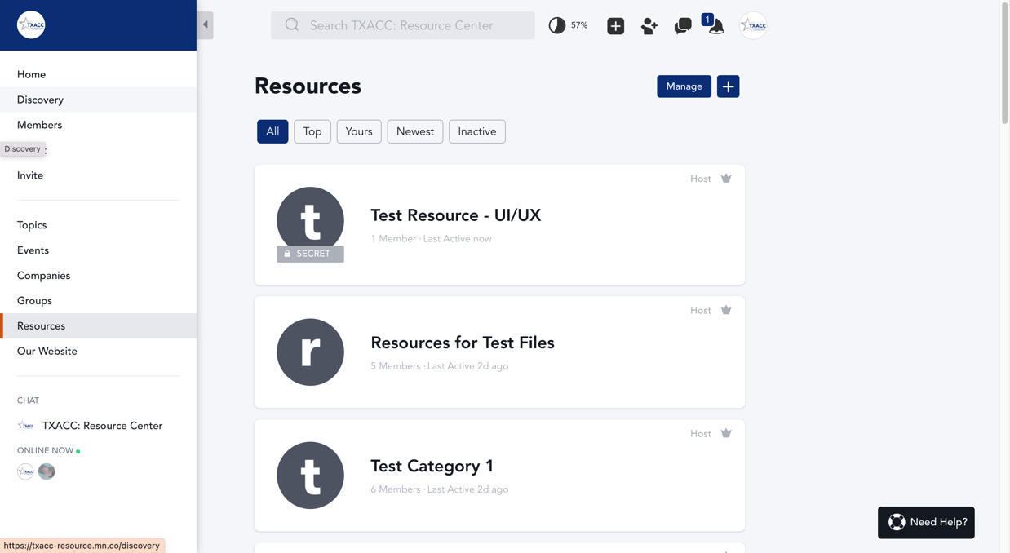

1. Click on the avatar on the top right corner > Resource Settings

NOTE: Only the hosts/admins of the resource will see the option for “Resource Settings”. Being an admin of the Mighty Network **will not guarantee** that you have access to all resources as an admin, as the resource might be created by another admin. If you do not see “Resource Settings” show up when entering the resource, **check with other admins for access to the resource.**

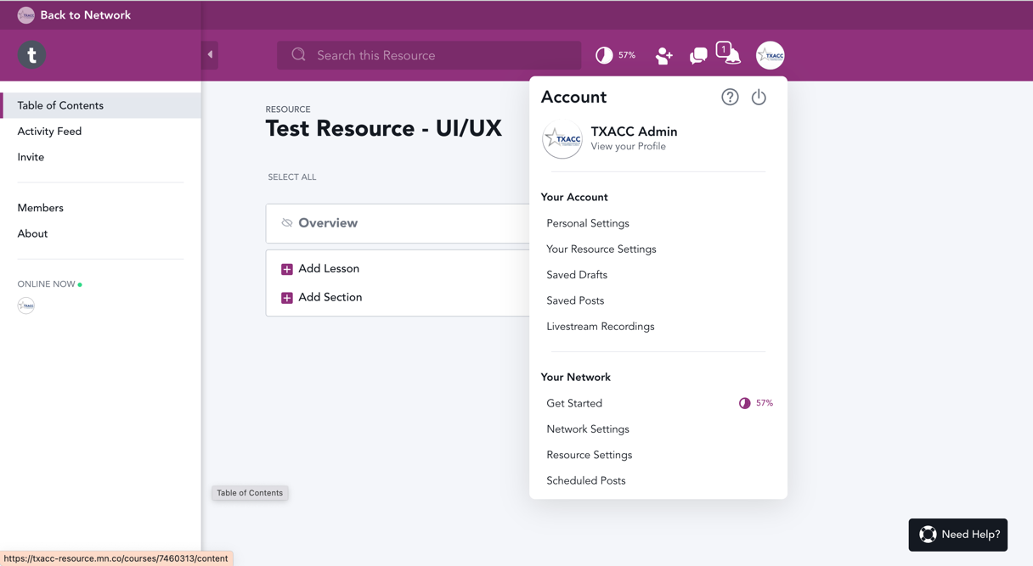

1. Click on “General Settings”

NOTE: The general settings and settings option of the Resource will be the same as the general settings of the Network. Check AdminGuide_UIUX_NetworkSettings if you want to check in details information about the General Settings in the Resource.

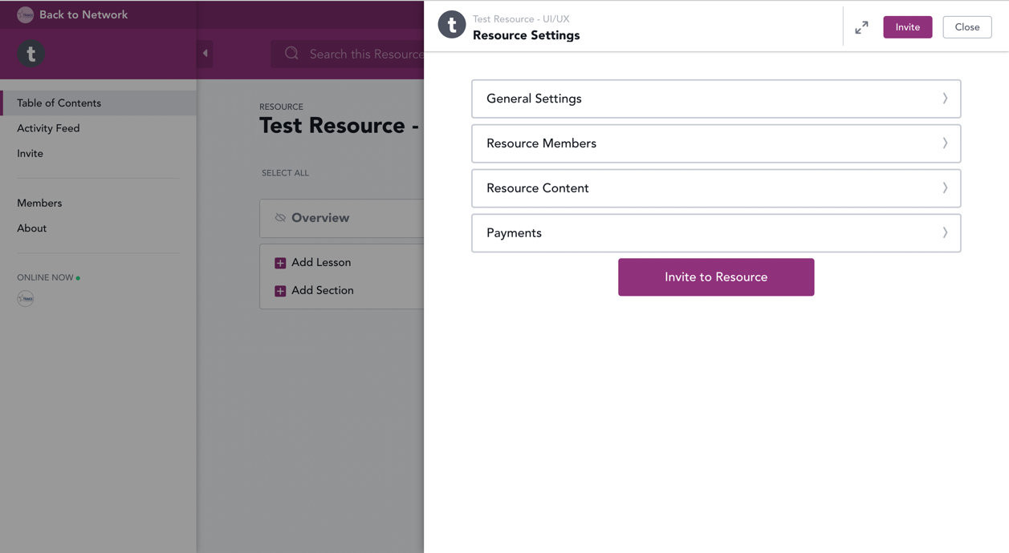

1. Navigate to Resource Branding section > Manage

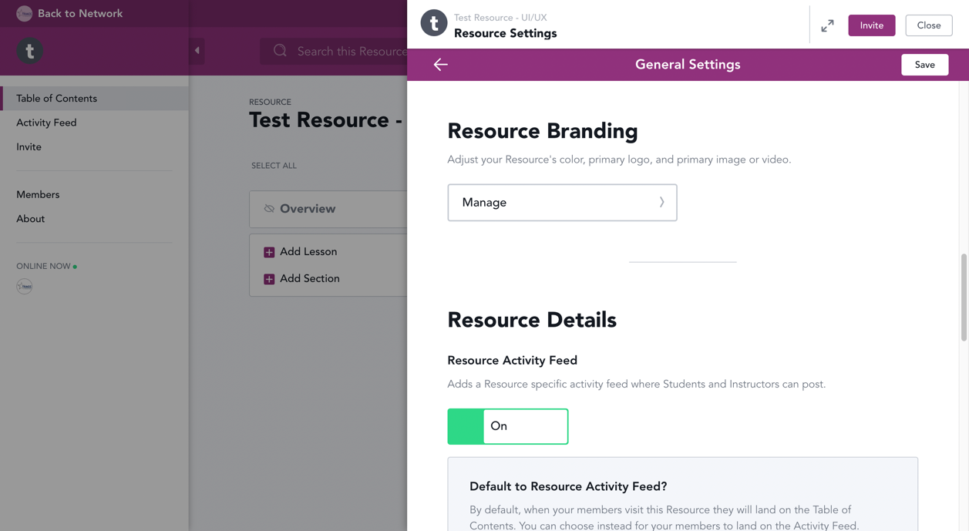

1. Click on the color or the color code next to Theme Color to make adjustments.

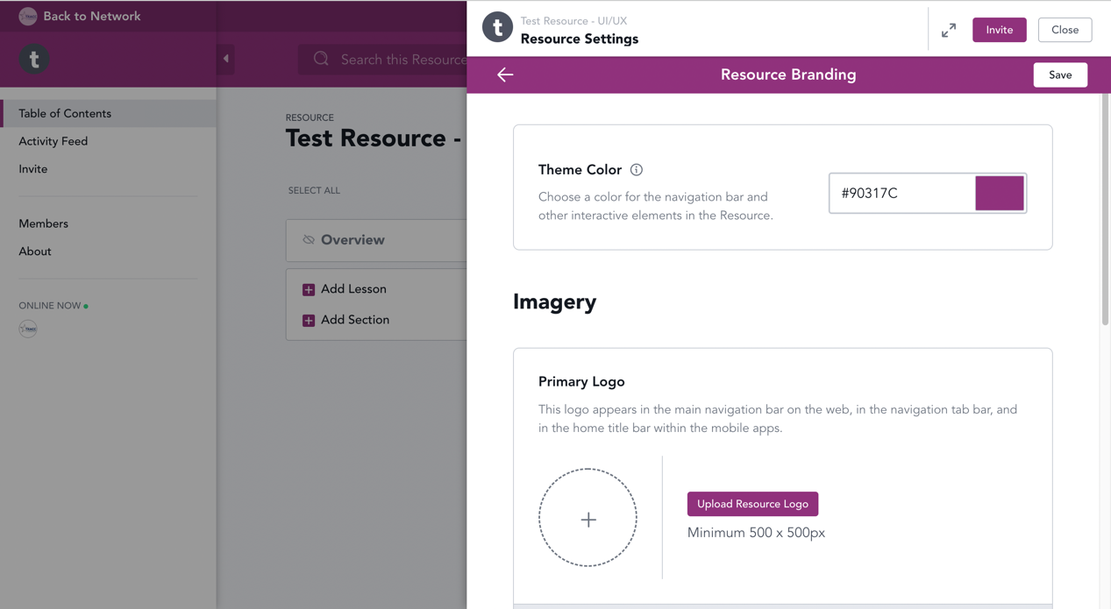

1. Navigate to the color code textbox.

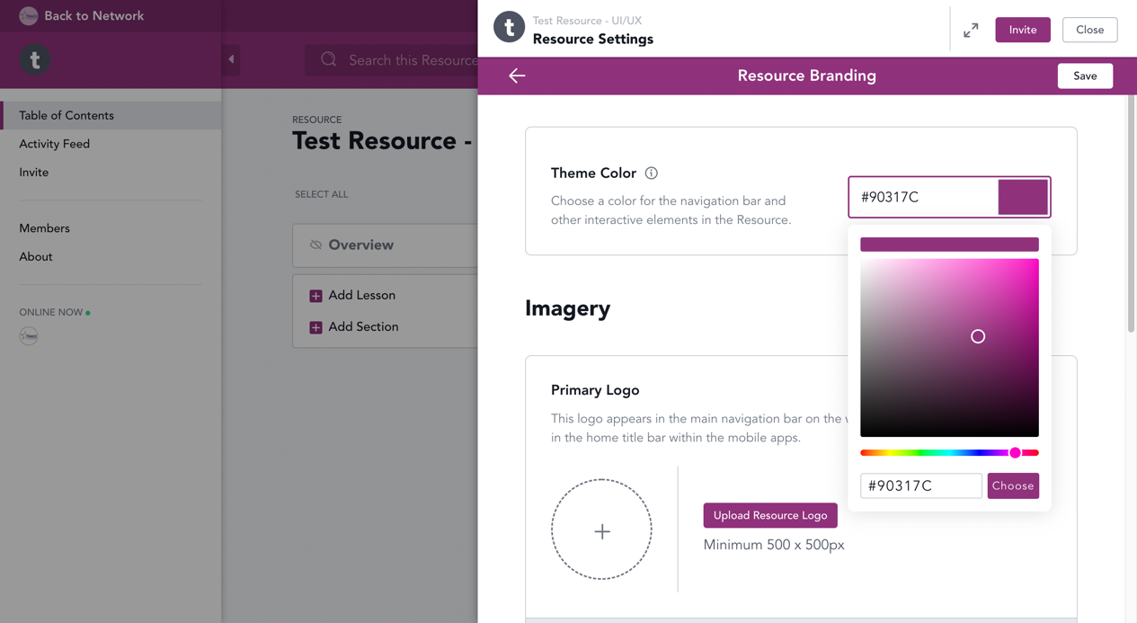

1. Type in “092D74”, then hit Choose > Save > Close.

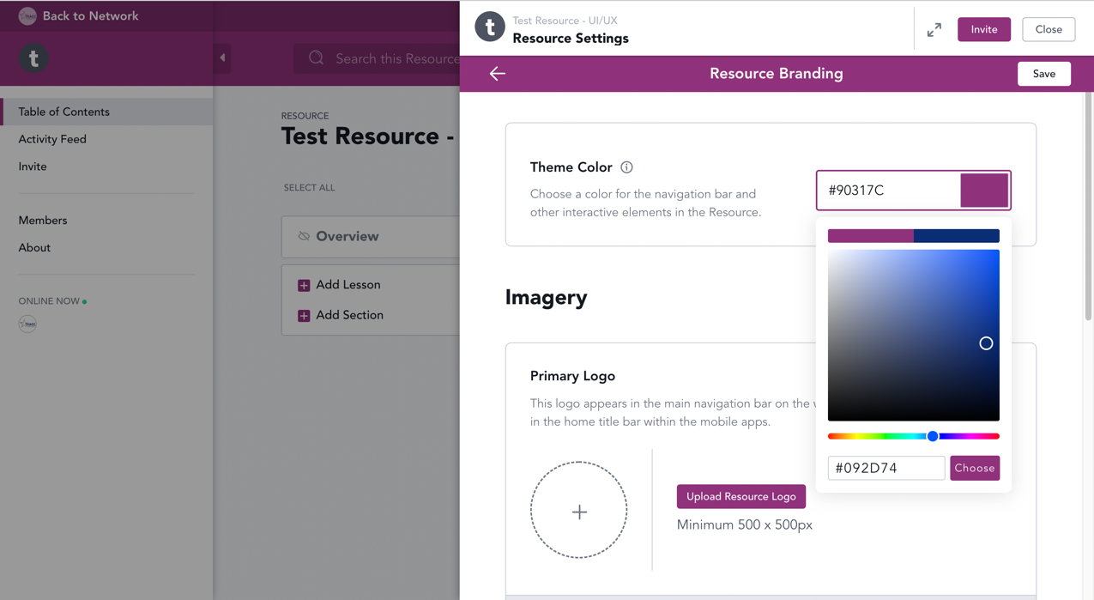

1. The change will now be visible in your Resource.

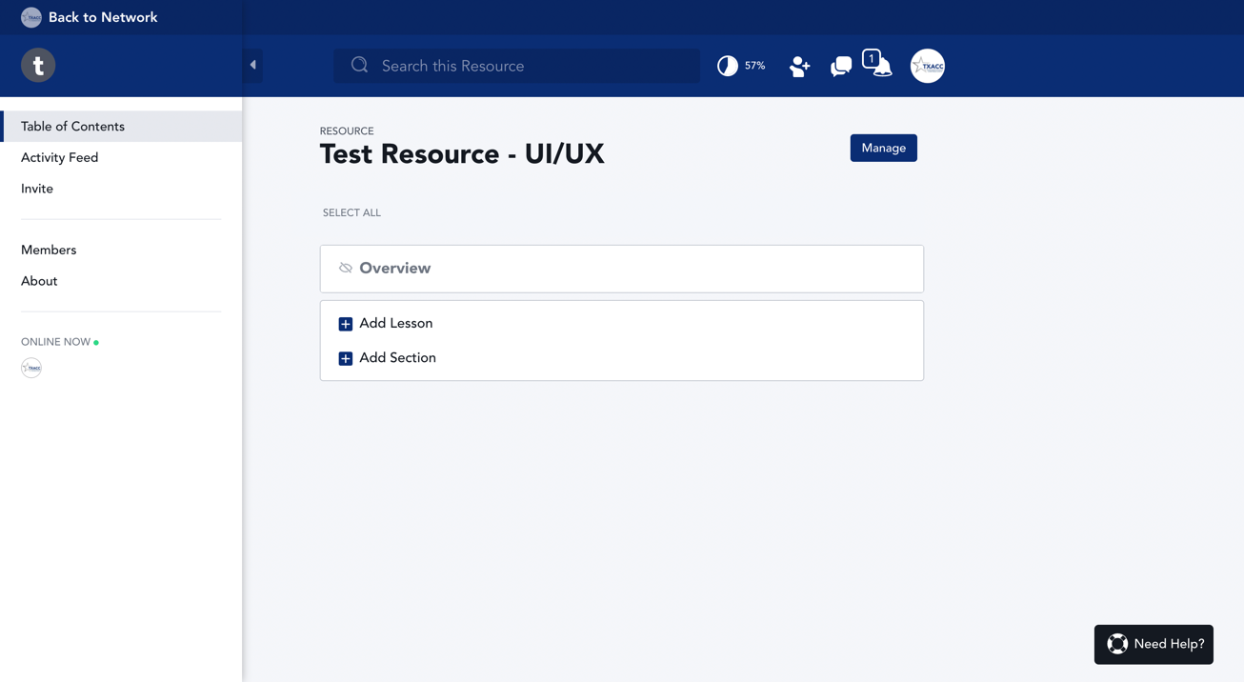

## Branding in Group – Group Settings

1. After logging in as an admin, at the homepage, navigate to Group on the menu pane on the left-hand side.

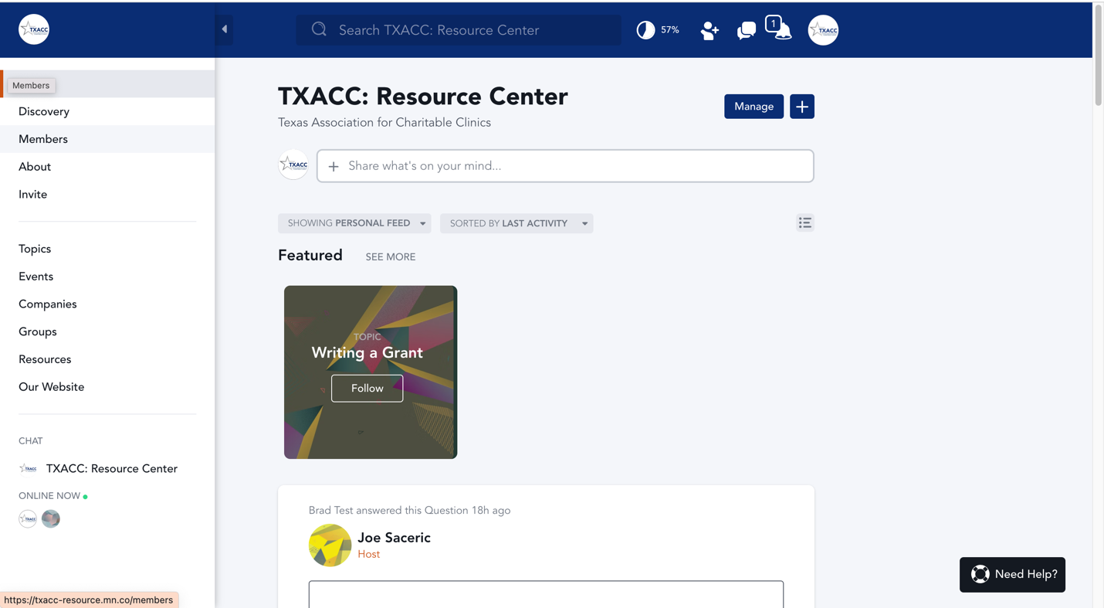

NOTE: Unlike Network Settings, the Settings for Group will only apply to one group only. Therefore, to make the newly created Resource complies with TXACC’s branding guidelines, you need to **make an adjustment to the branding color of the Group every time you create a new Group.**

1. Click on the newly created Group or the Group you want to make adjustment.

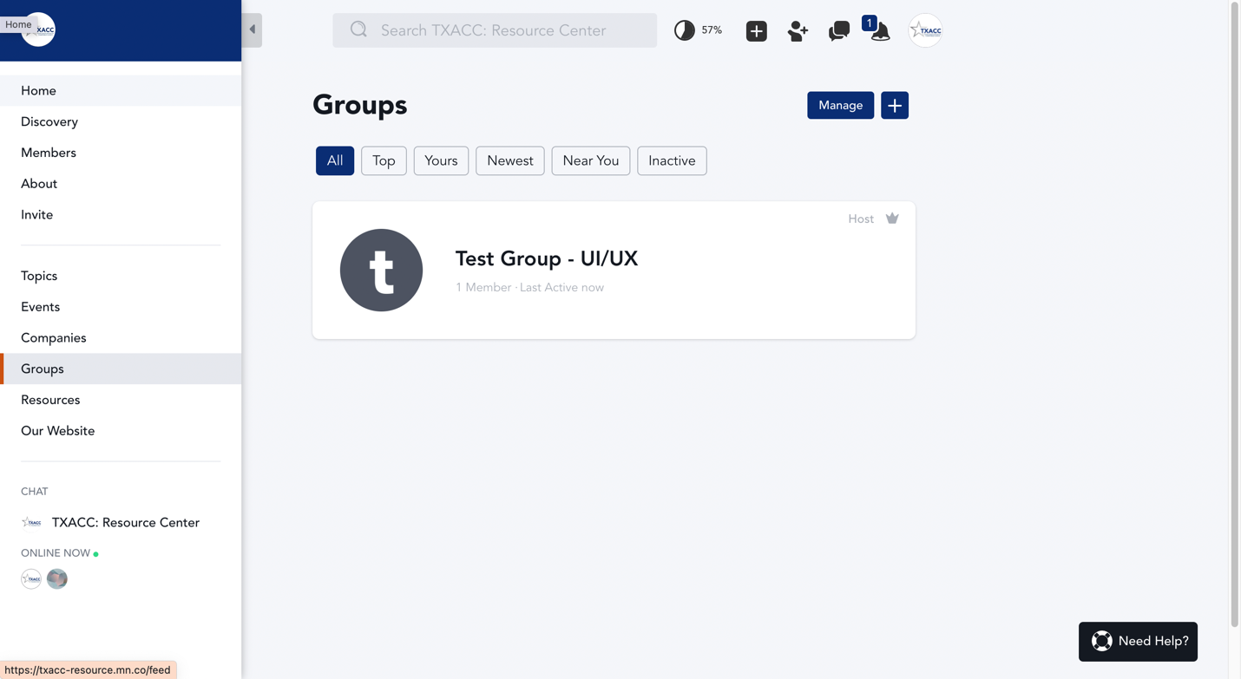

1. Click on the avatar on the top right corner > Group Settings

NOTE: Only the hosts/admins of the group will see the option for “Group Settings”. Being an admin of the Mighty Network **will not guarantee** that you have access to all groups as an admin of the group, since the group might be created by another admin. If you do not see “Group Settings” show up when entering the group, **check with other admins to see your current role in the group.** Other admins can assign you as an admin of the group.

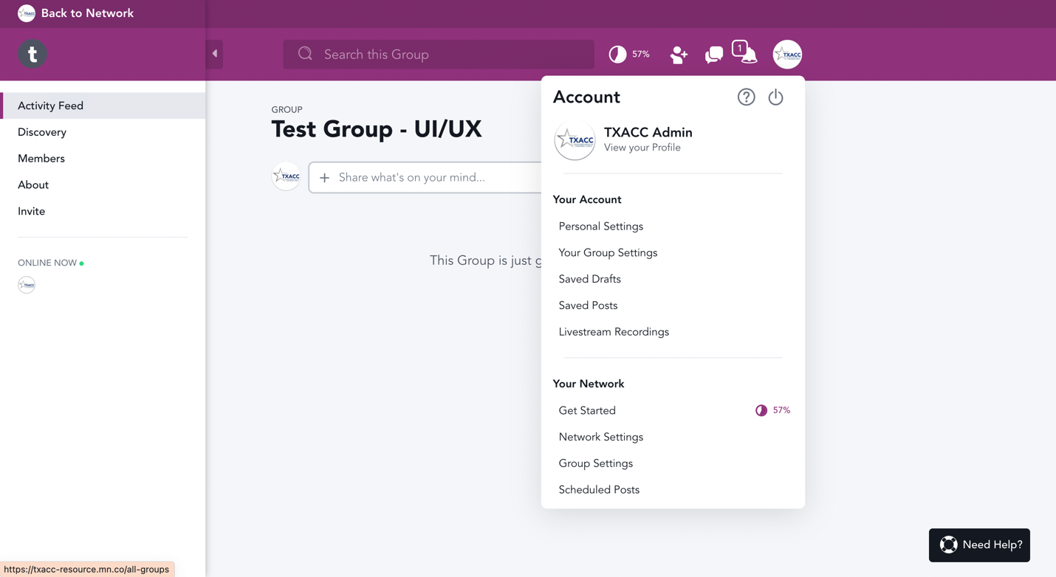

1. Click on “General Settings”

NOTE: The general settings and settings option of the Group will be the same as the general settings of the Network. Check AdminGuide_UIUX_NetworkSettings if you want to check in details information about the General Settings in the Group.

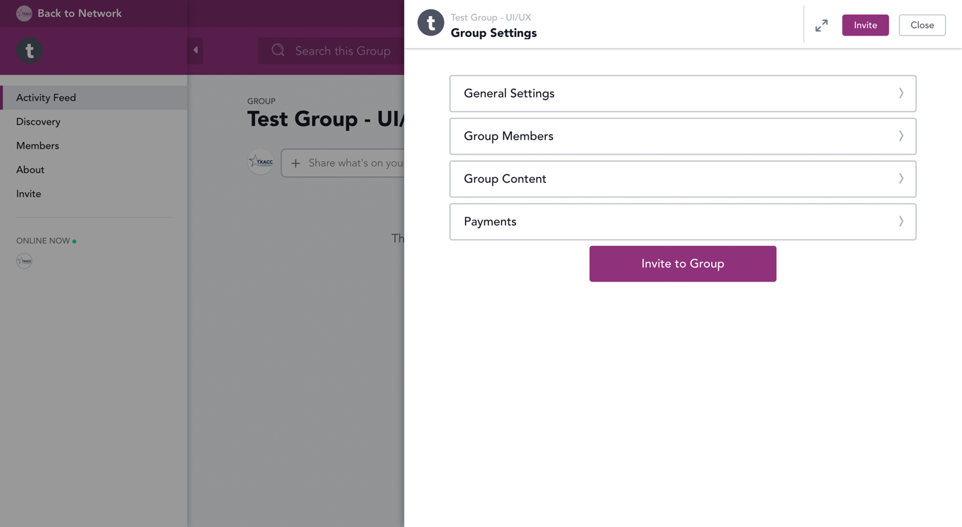

1. Navigate to Group Branding section > Manage

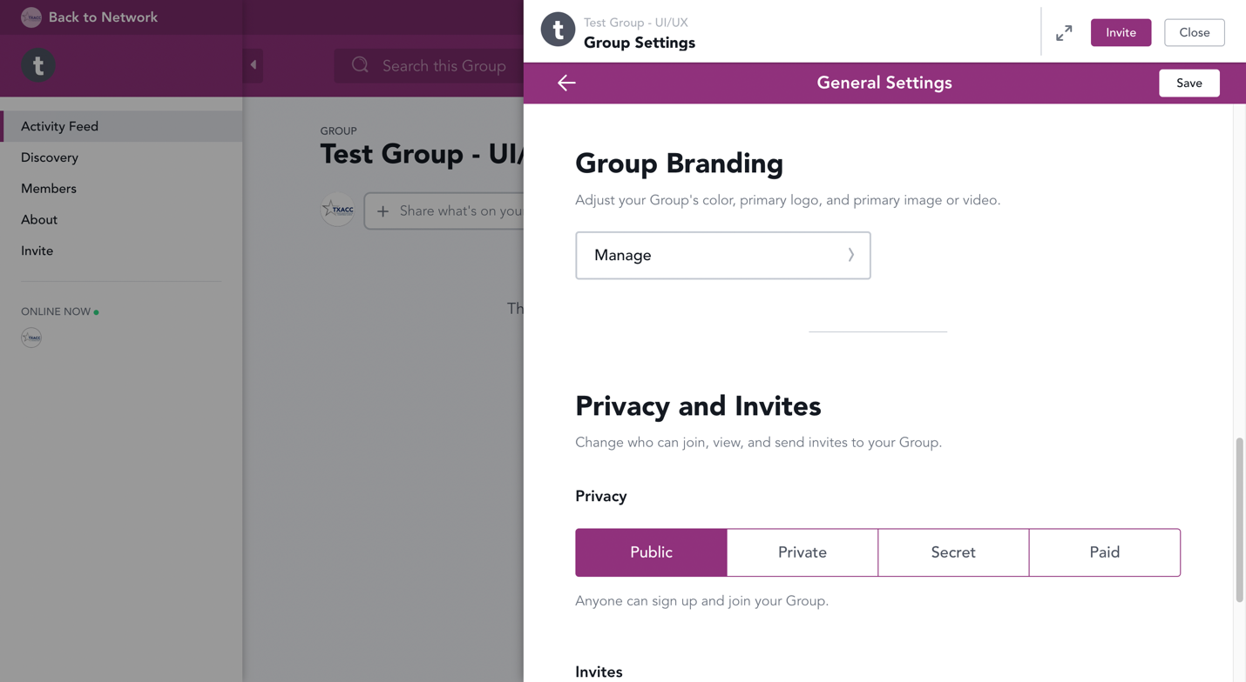

1. Click on the color or the color code next to Theme Color to make adjustments.

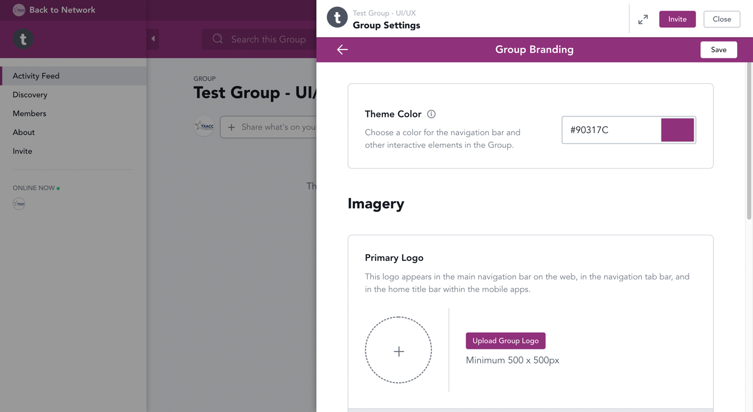

1. Navigate to the color code textbox.

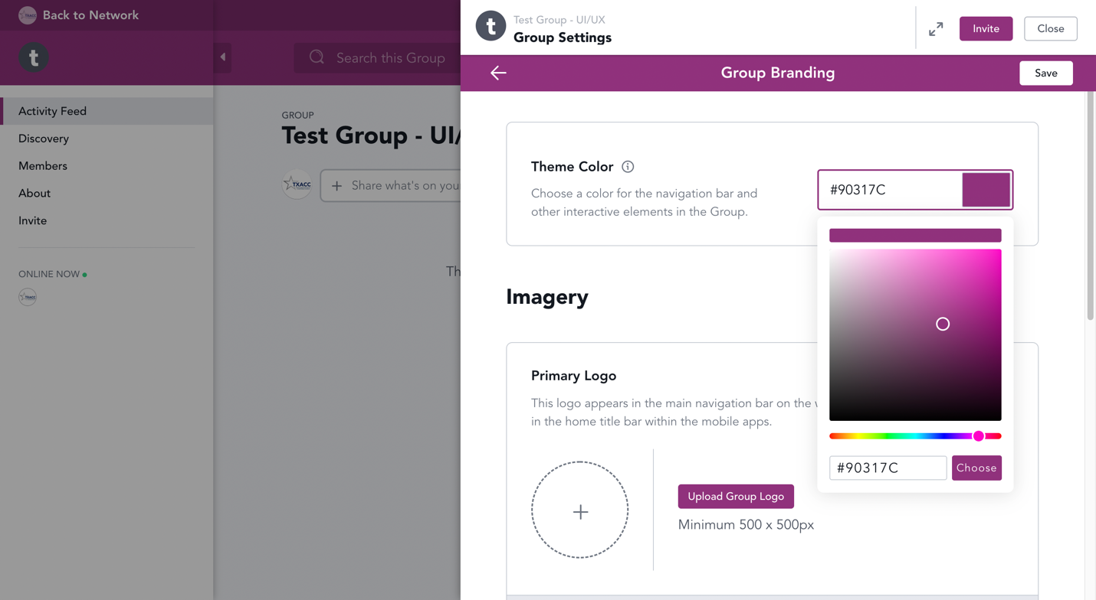

1. Type in “092D74”, then hit Choose > Save > Close.

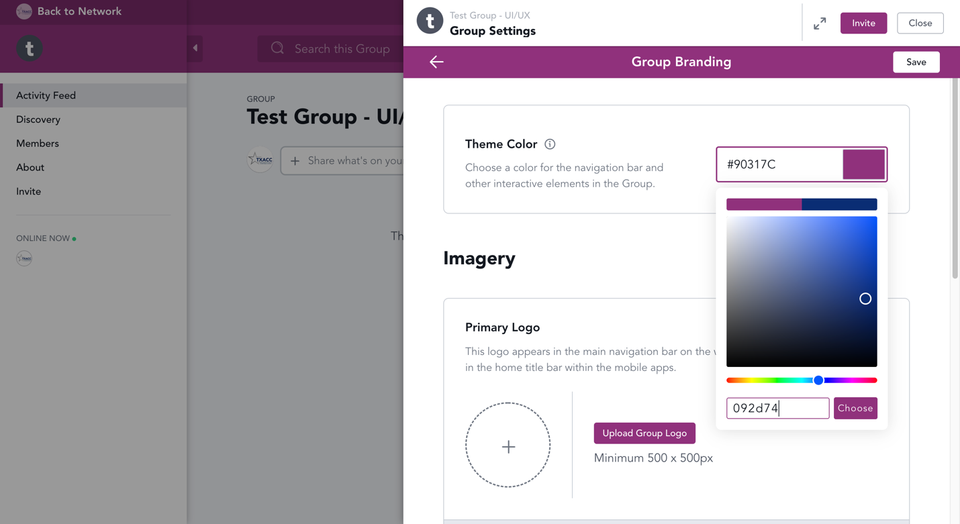

1. The change will now be visible in your Resource.

